AWS Setup

Open this in Google docs so you can see the comments.

Sign in to AWS - select DynamoDB form services menu.

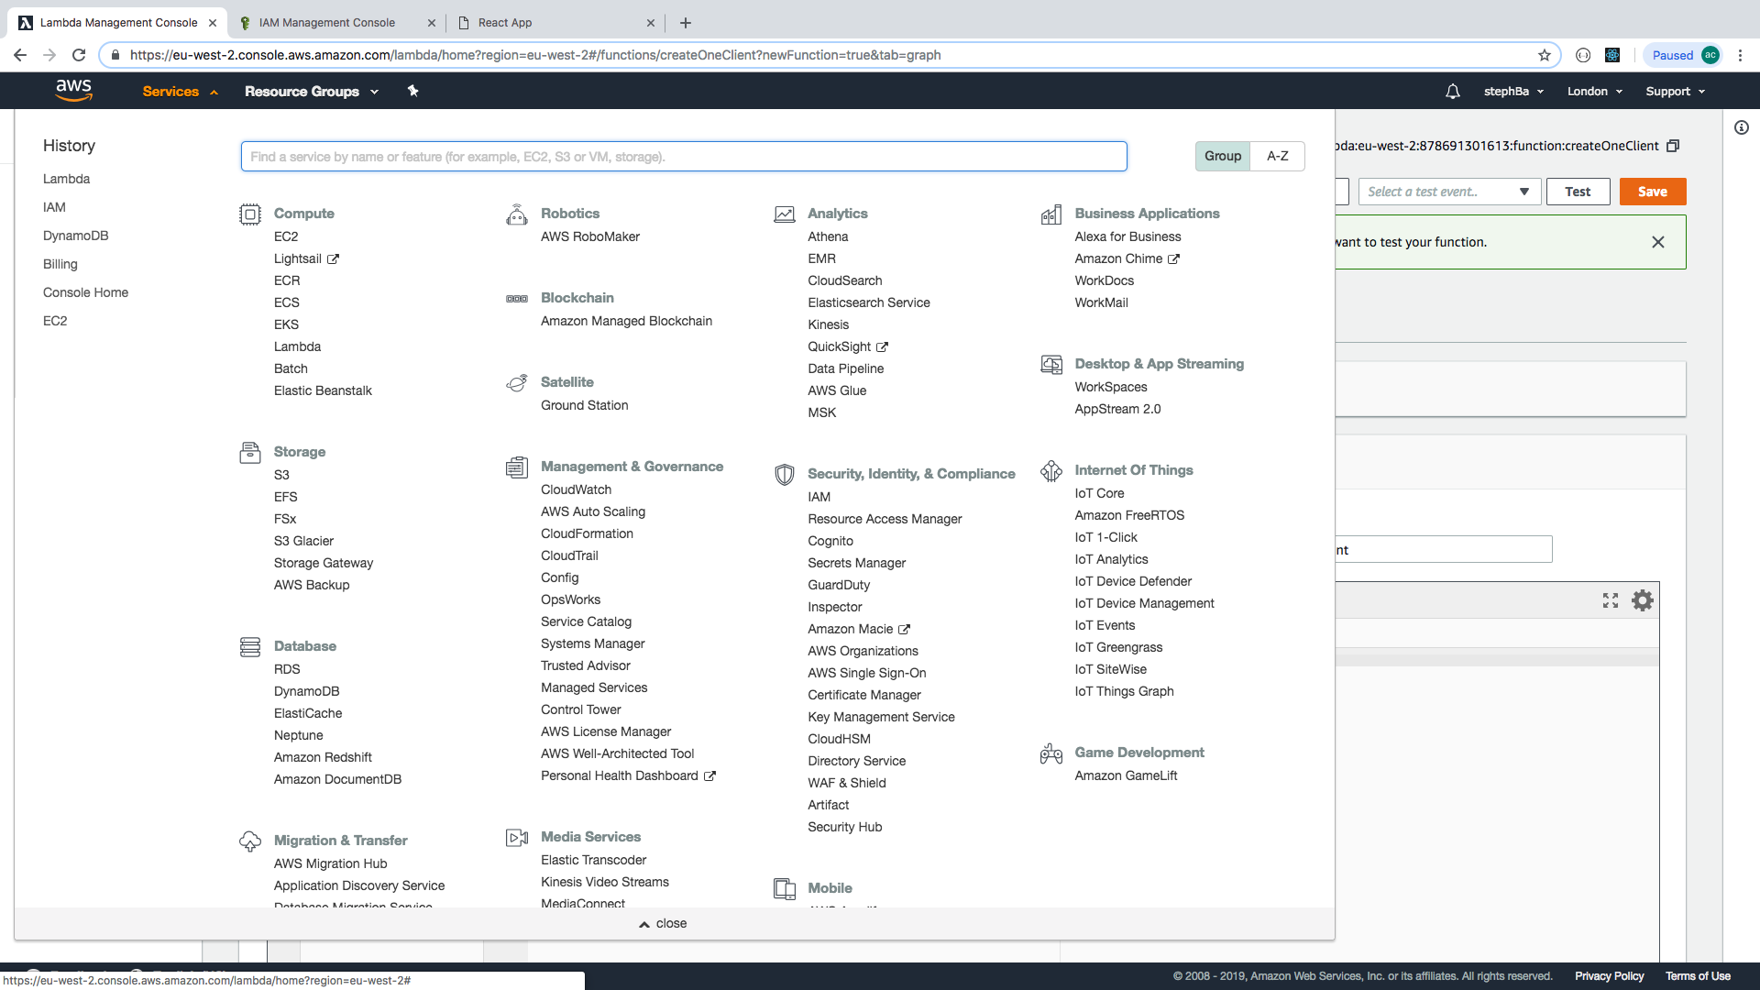

**Set Up dynamoDB**

Create Table:

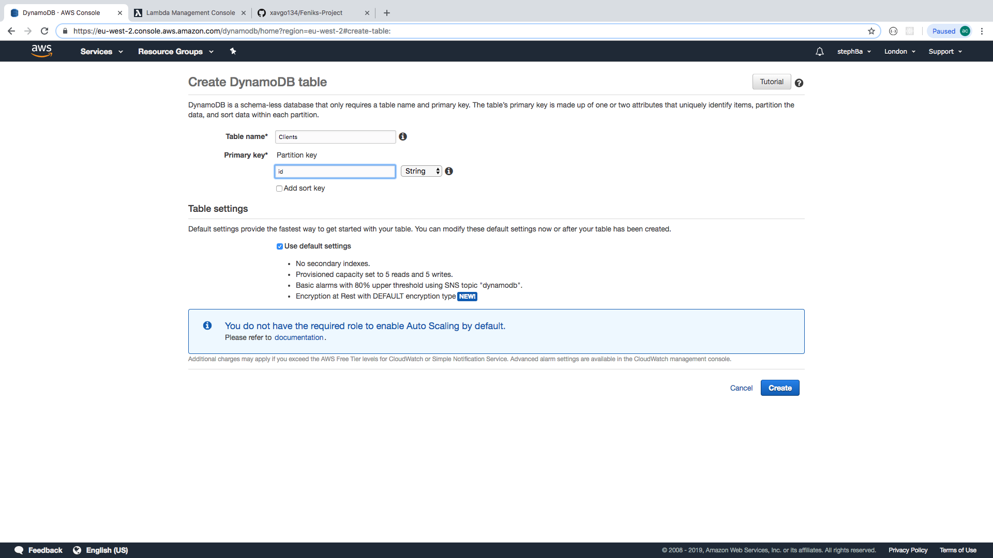

For example, this creates a non-relational database called ‘Clients’ with one primary key ‘id’

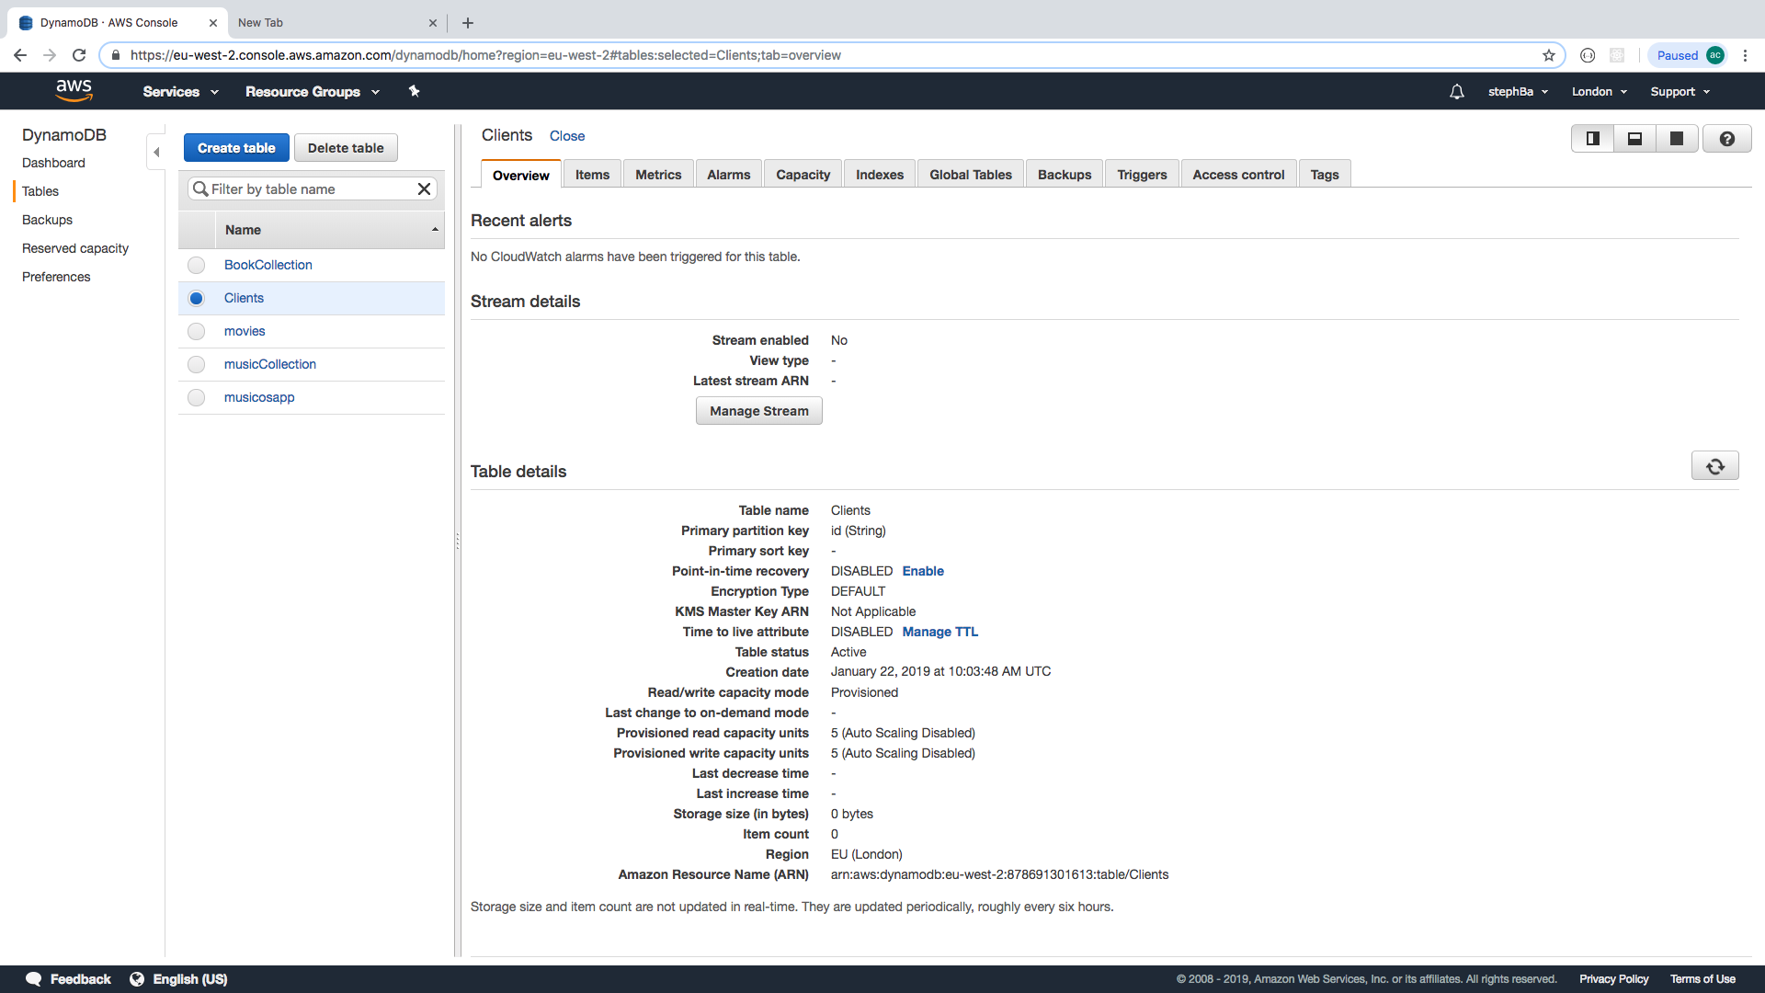

Create Lambda Function

Select Lambda from the services menu. Can be created from ‘functions’ or ‘dashboard’

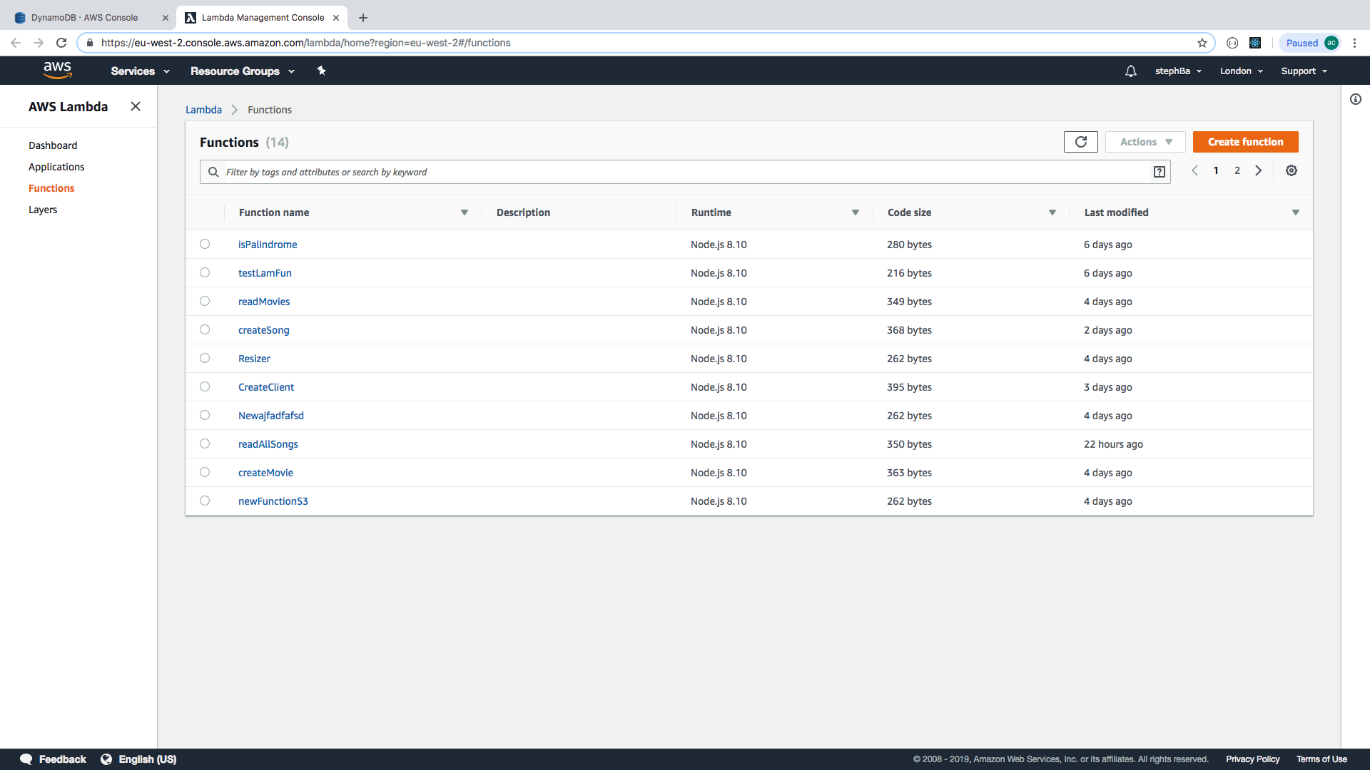

Select ‘create function’

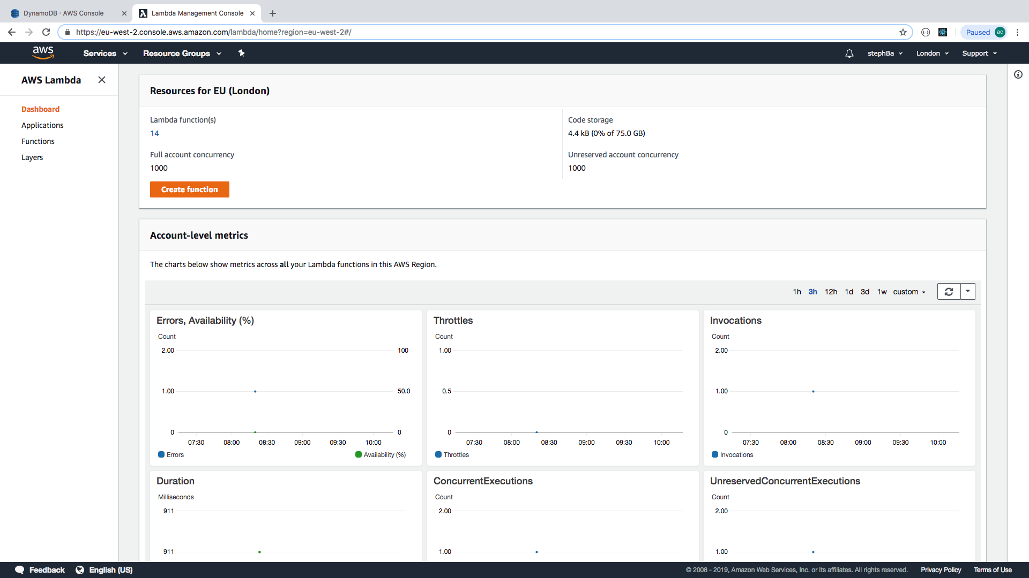

Then complete the details of the function:

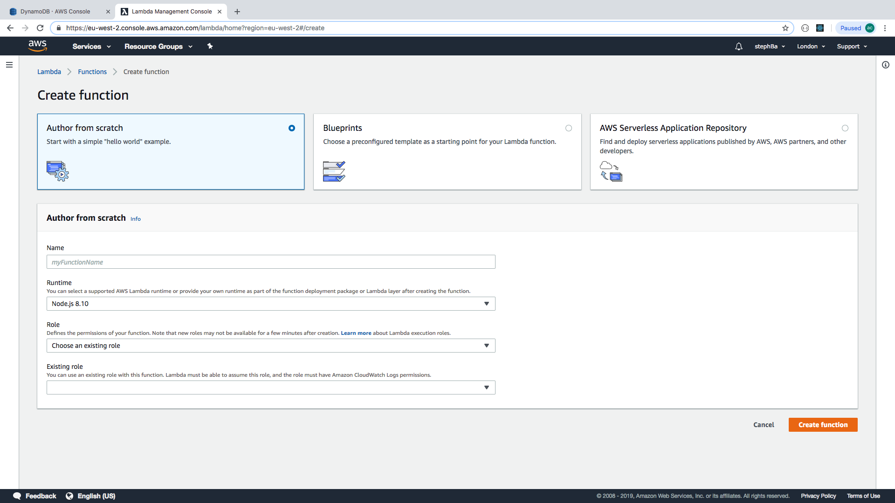

We are going to create the function to create a client.

Select the runtime, it defaults to node.js 8.10, which is what we want.

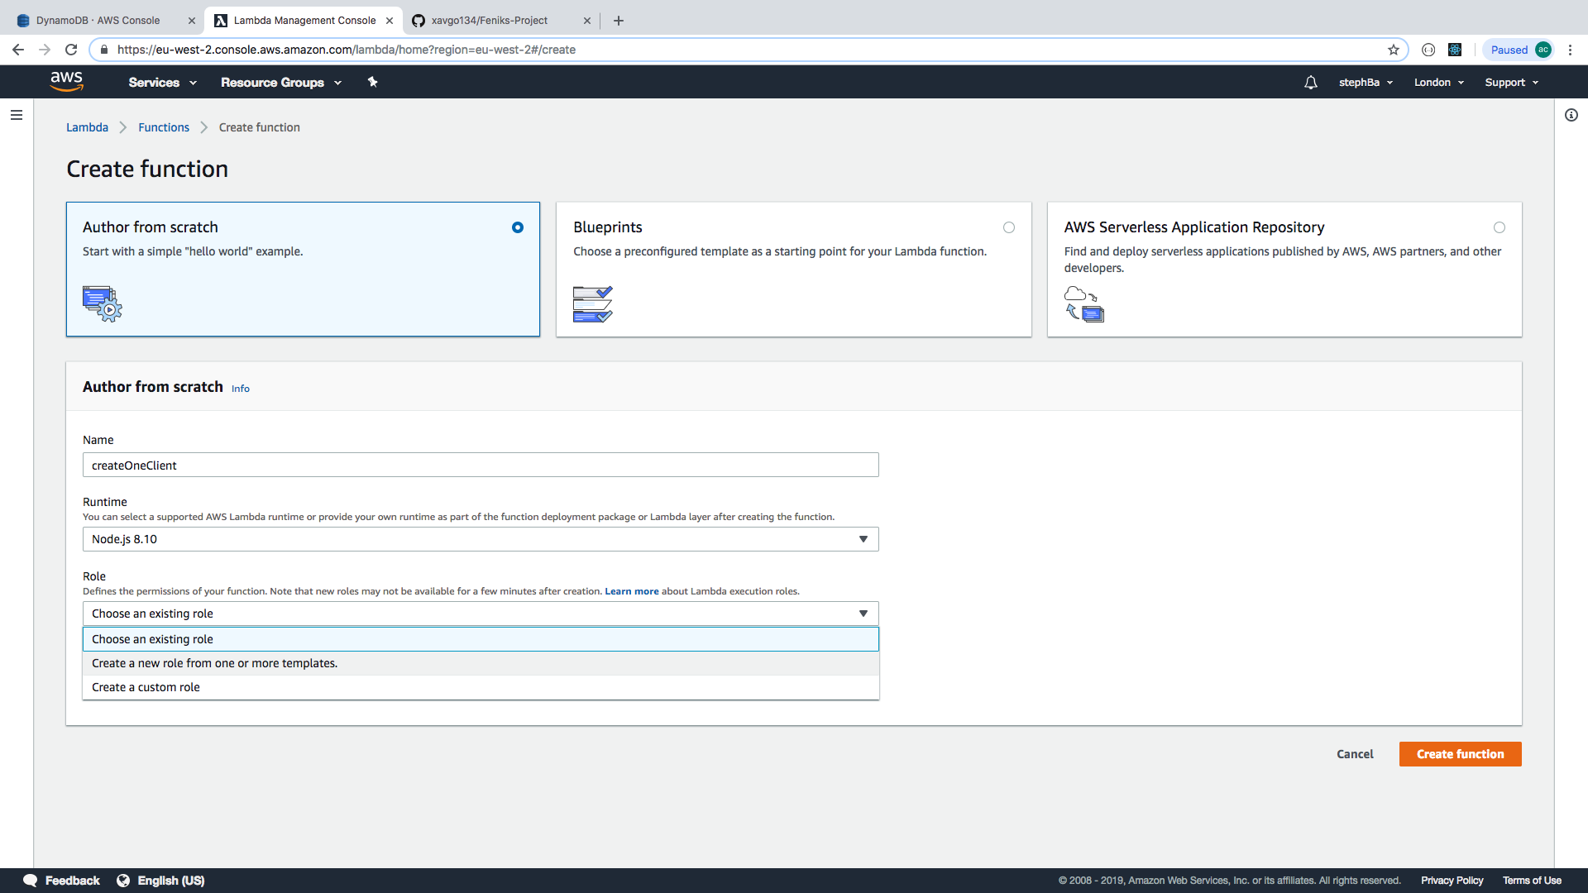

Select create a new role from one or more templates.

We have called it CreateOneClientRole:

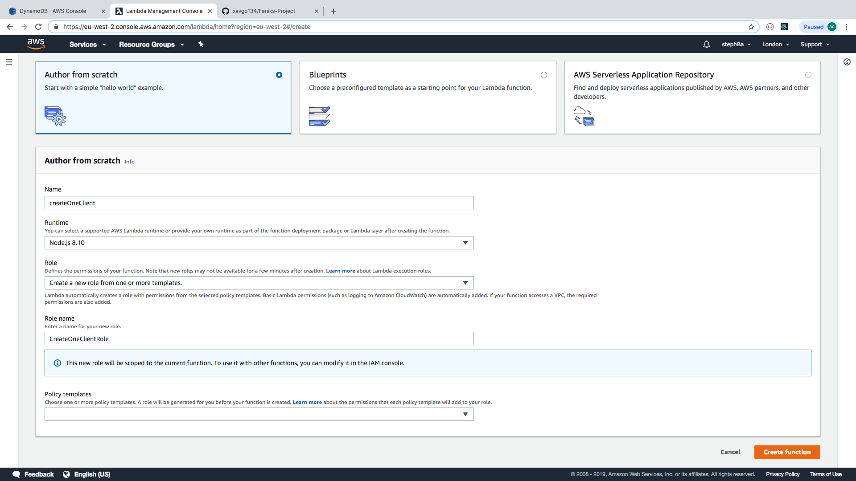

Hit create function.

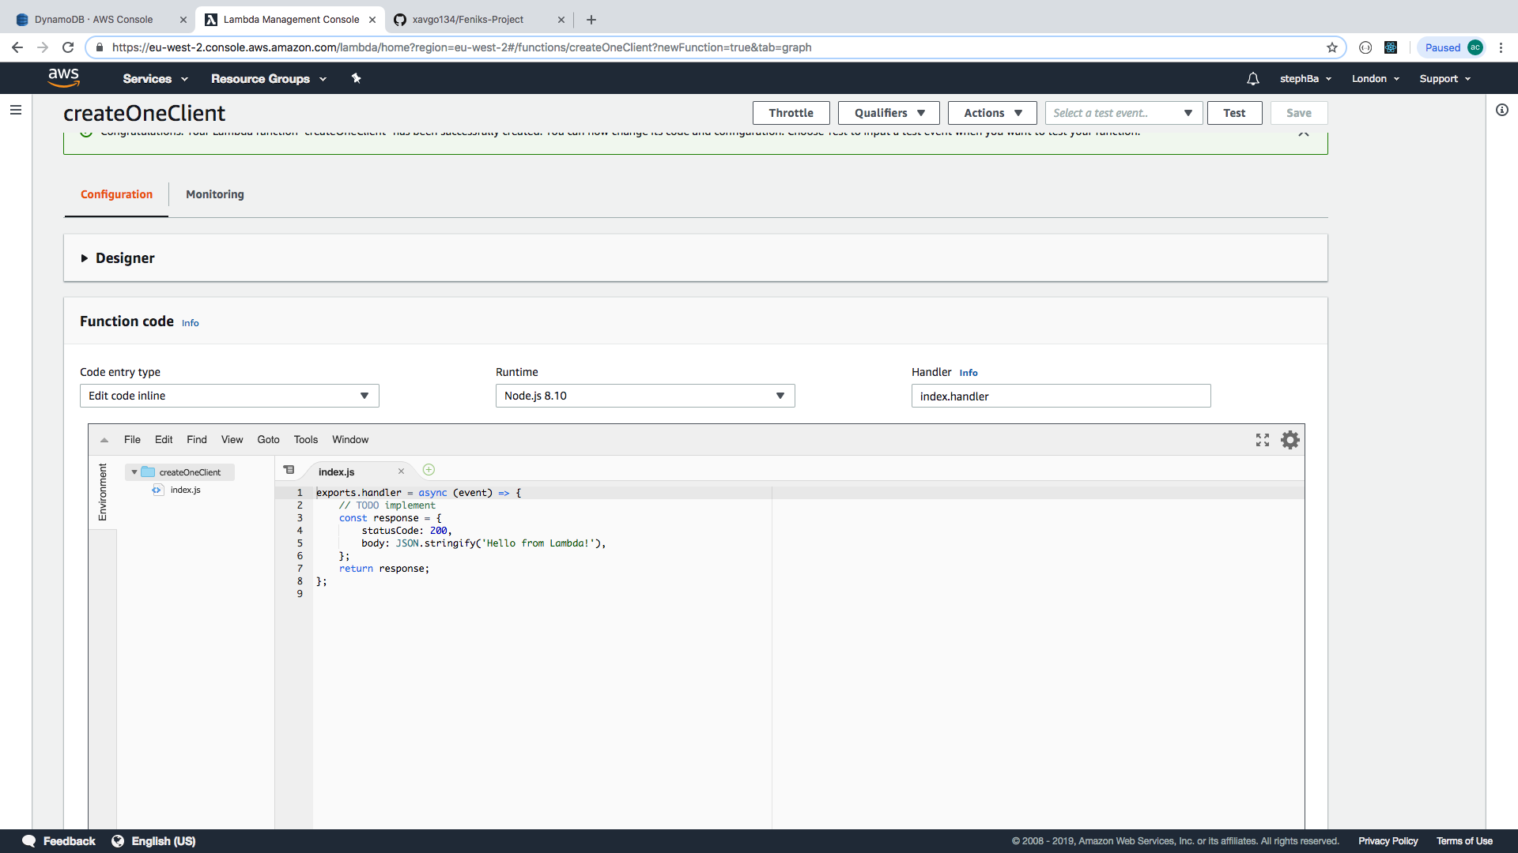

You get a template of exports.handler as a start point for writing your own function.

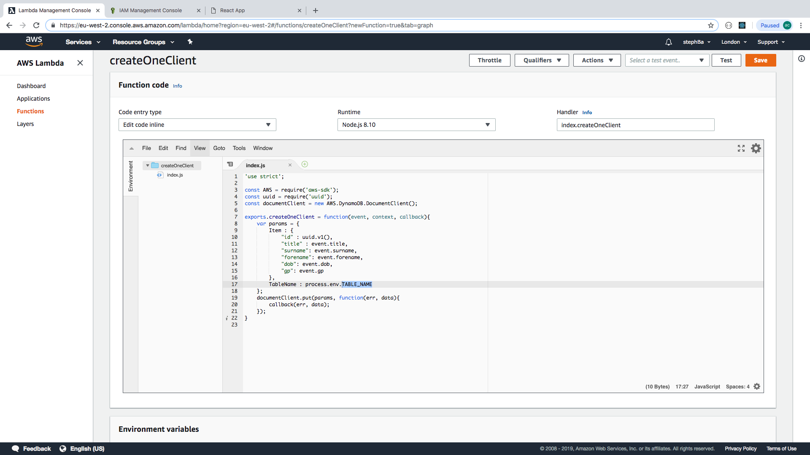

Note that the function name must be the same in handler info (index.xxx) as index.js (exports.xxx) Remember to save any changes.

Now set up the environment variable for TABLE_NAME to be the name of the table (Clients)

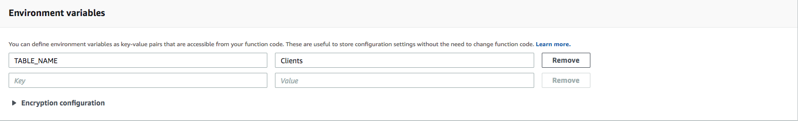

Set up IAM (Identity Access Management)

Select IAM from services menu

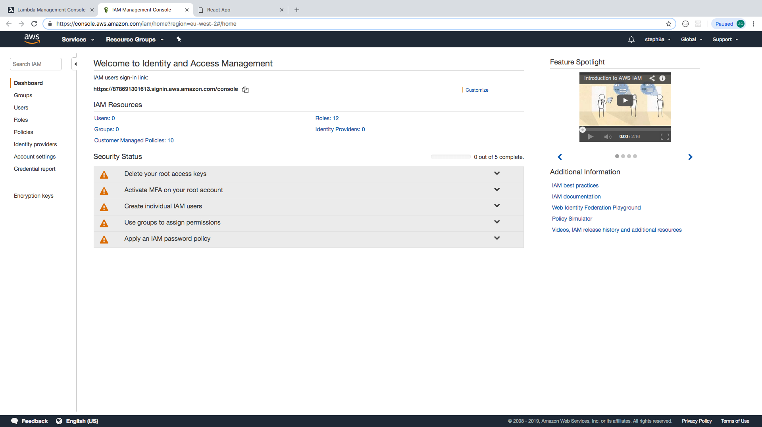

Select roles

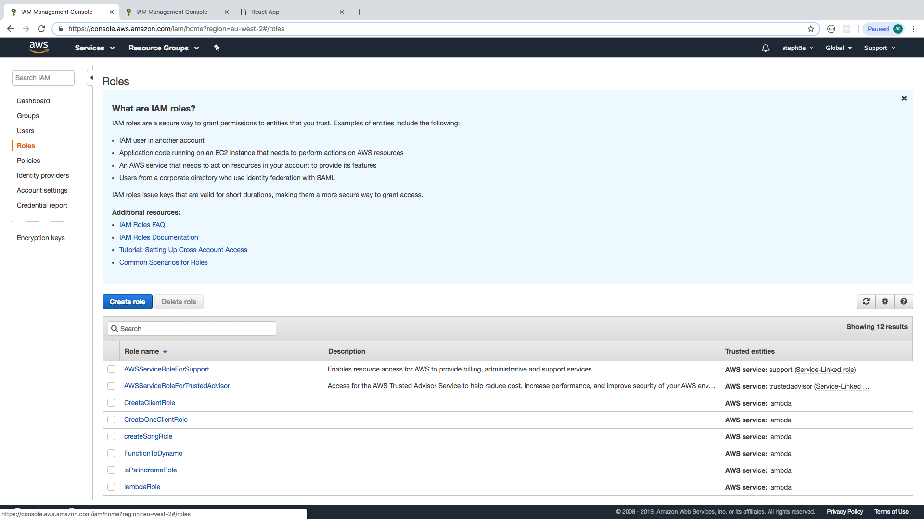

Select the role you created for the function

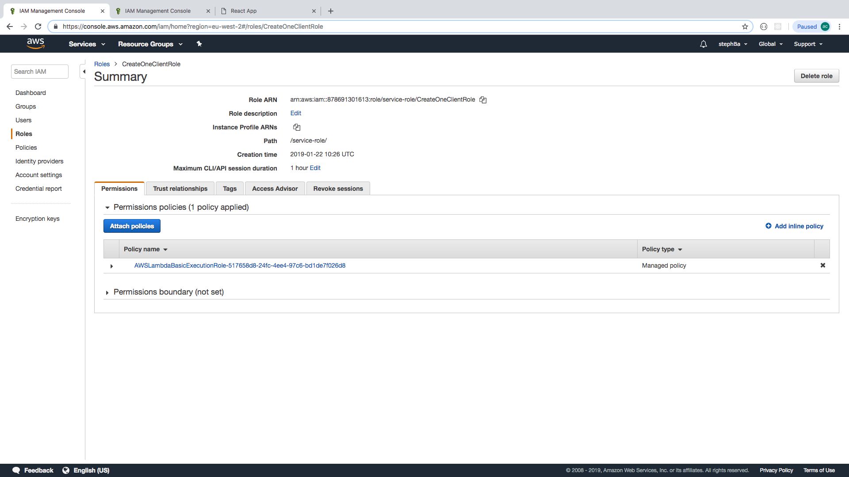

Select the policy name.

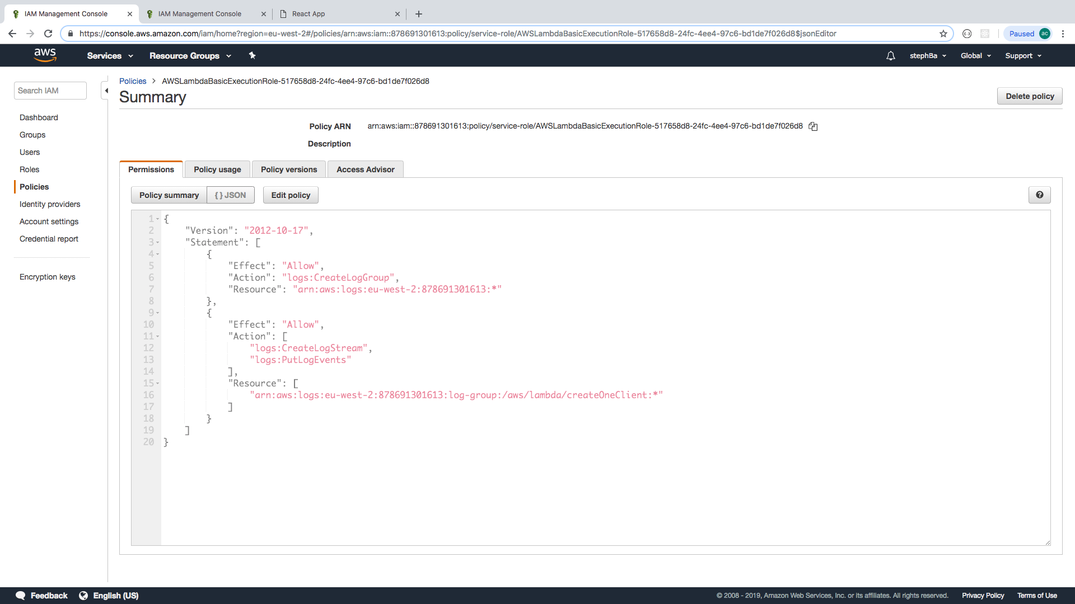

Select {}JSON to see the policy in a JSON format then click on ‘edit’ policy

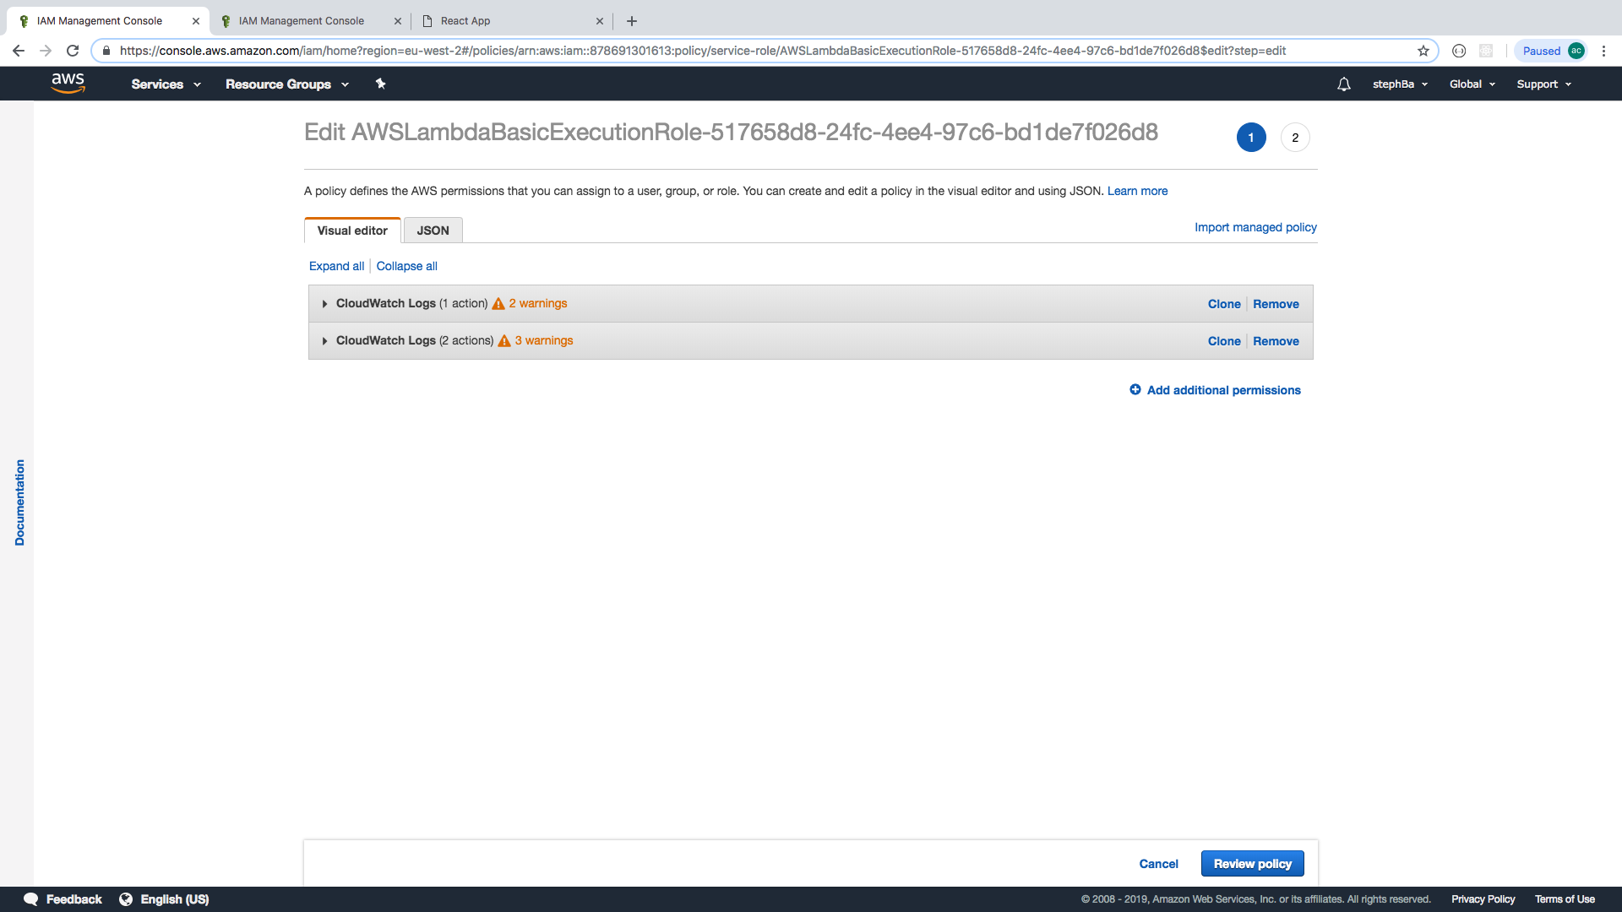

Then click on JSON to edit the code

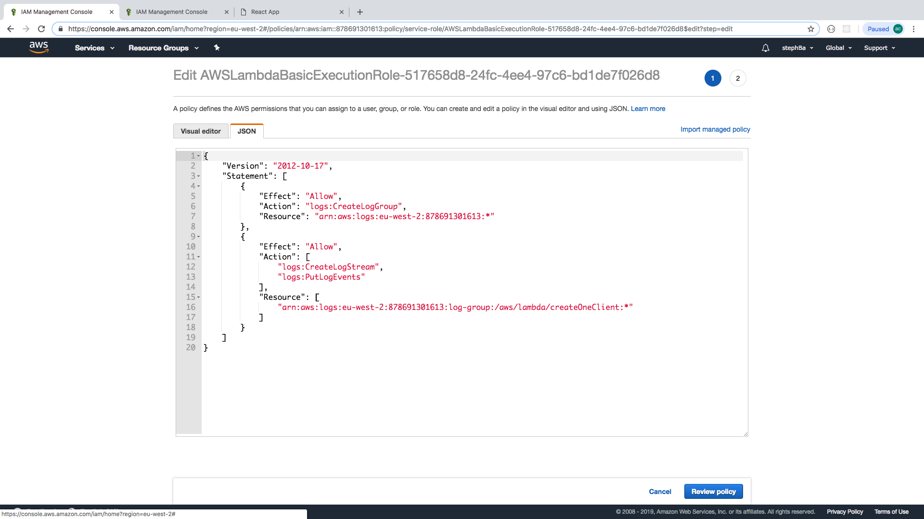

Now you need to edit the permissions:

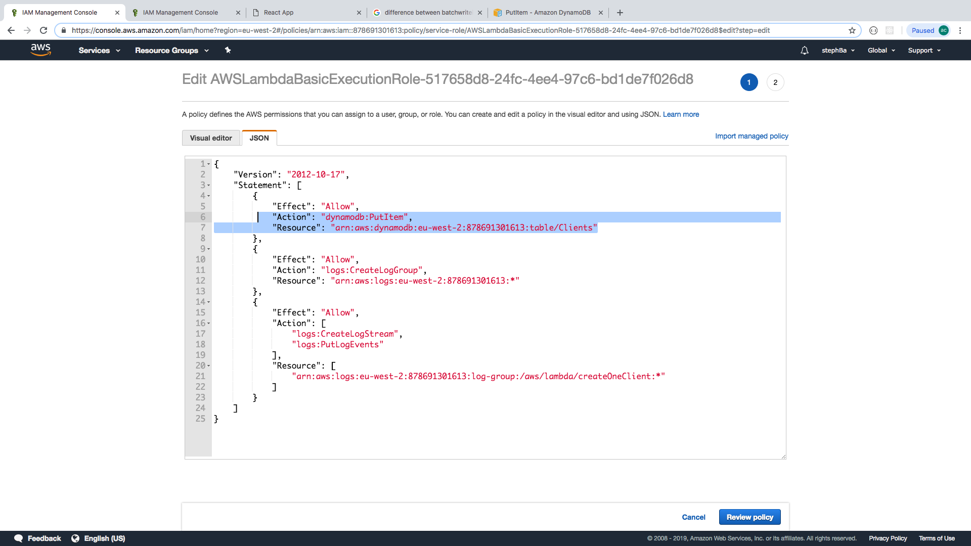

This adds:

1. Permission for the function to PutItem
2. Defines the resource based on the ARN.

Click on review policy then save changes:

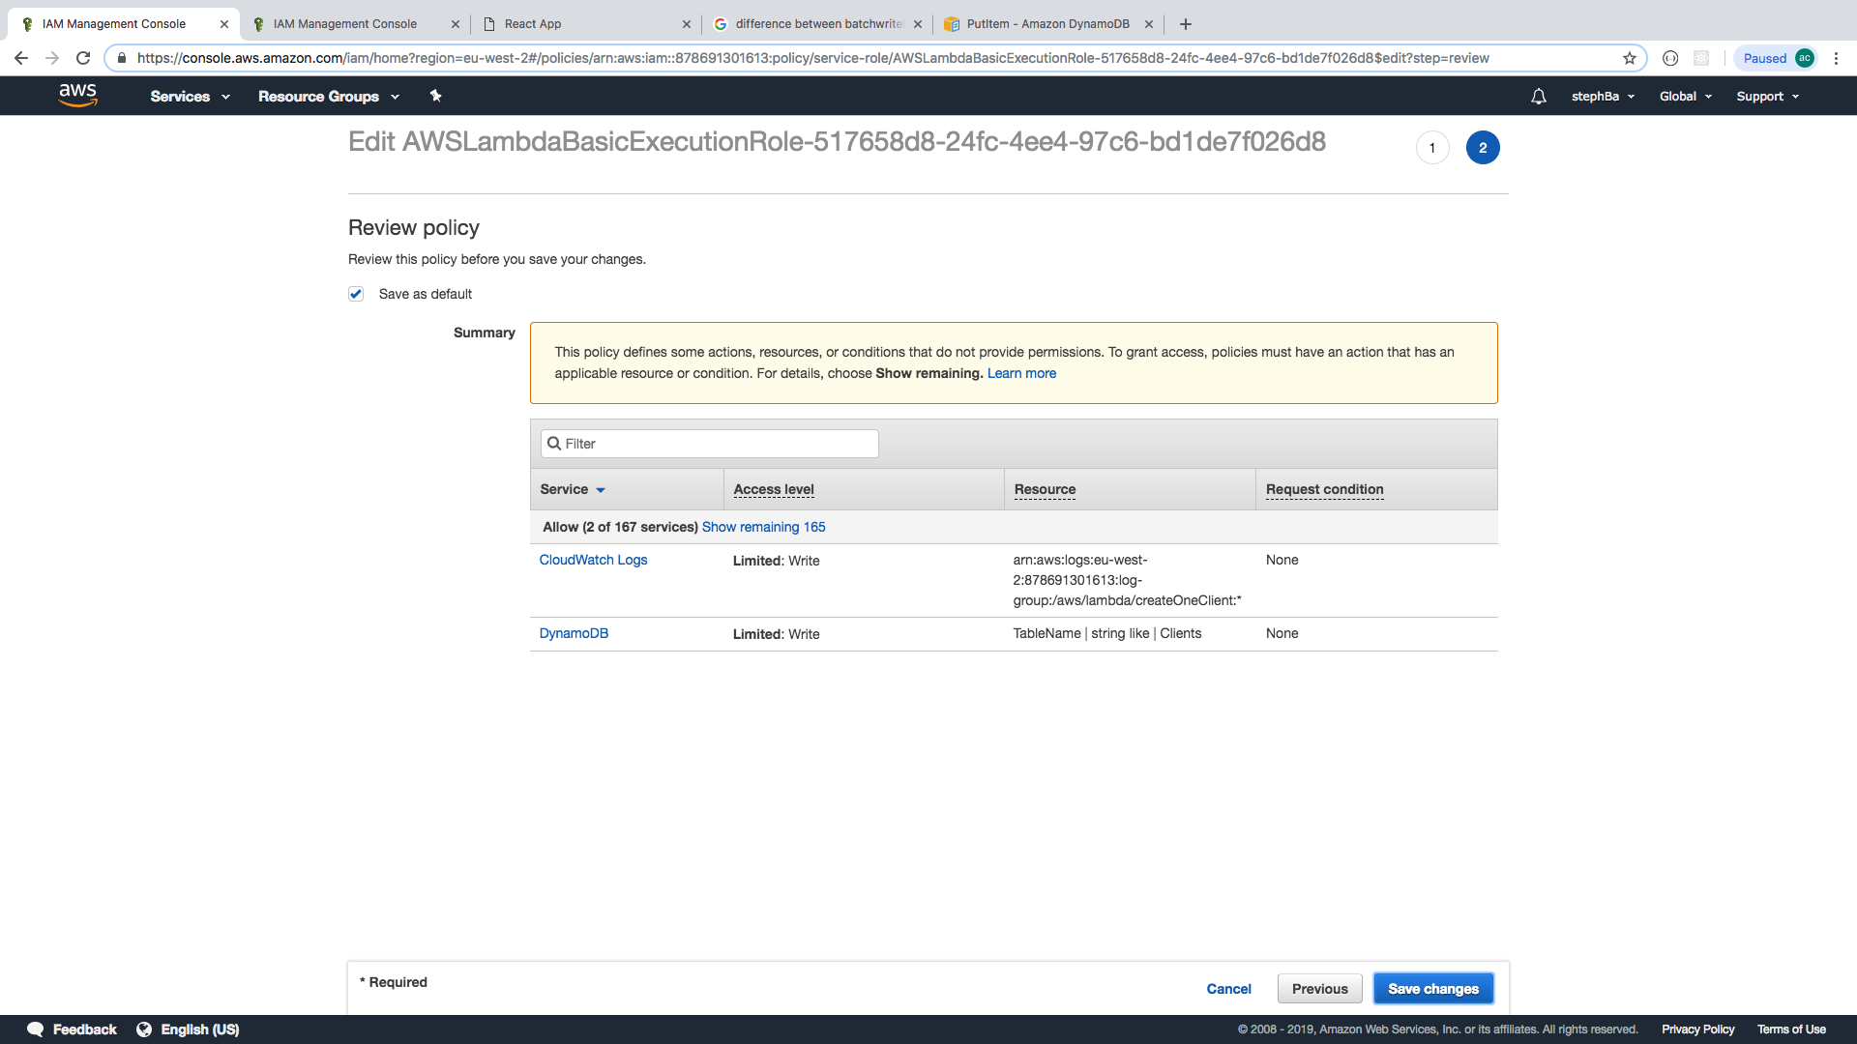

Go back to Lambda using the services menu. Select your function.

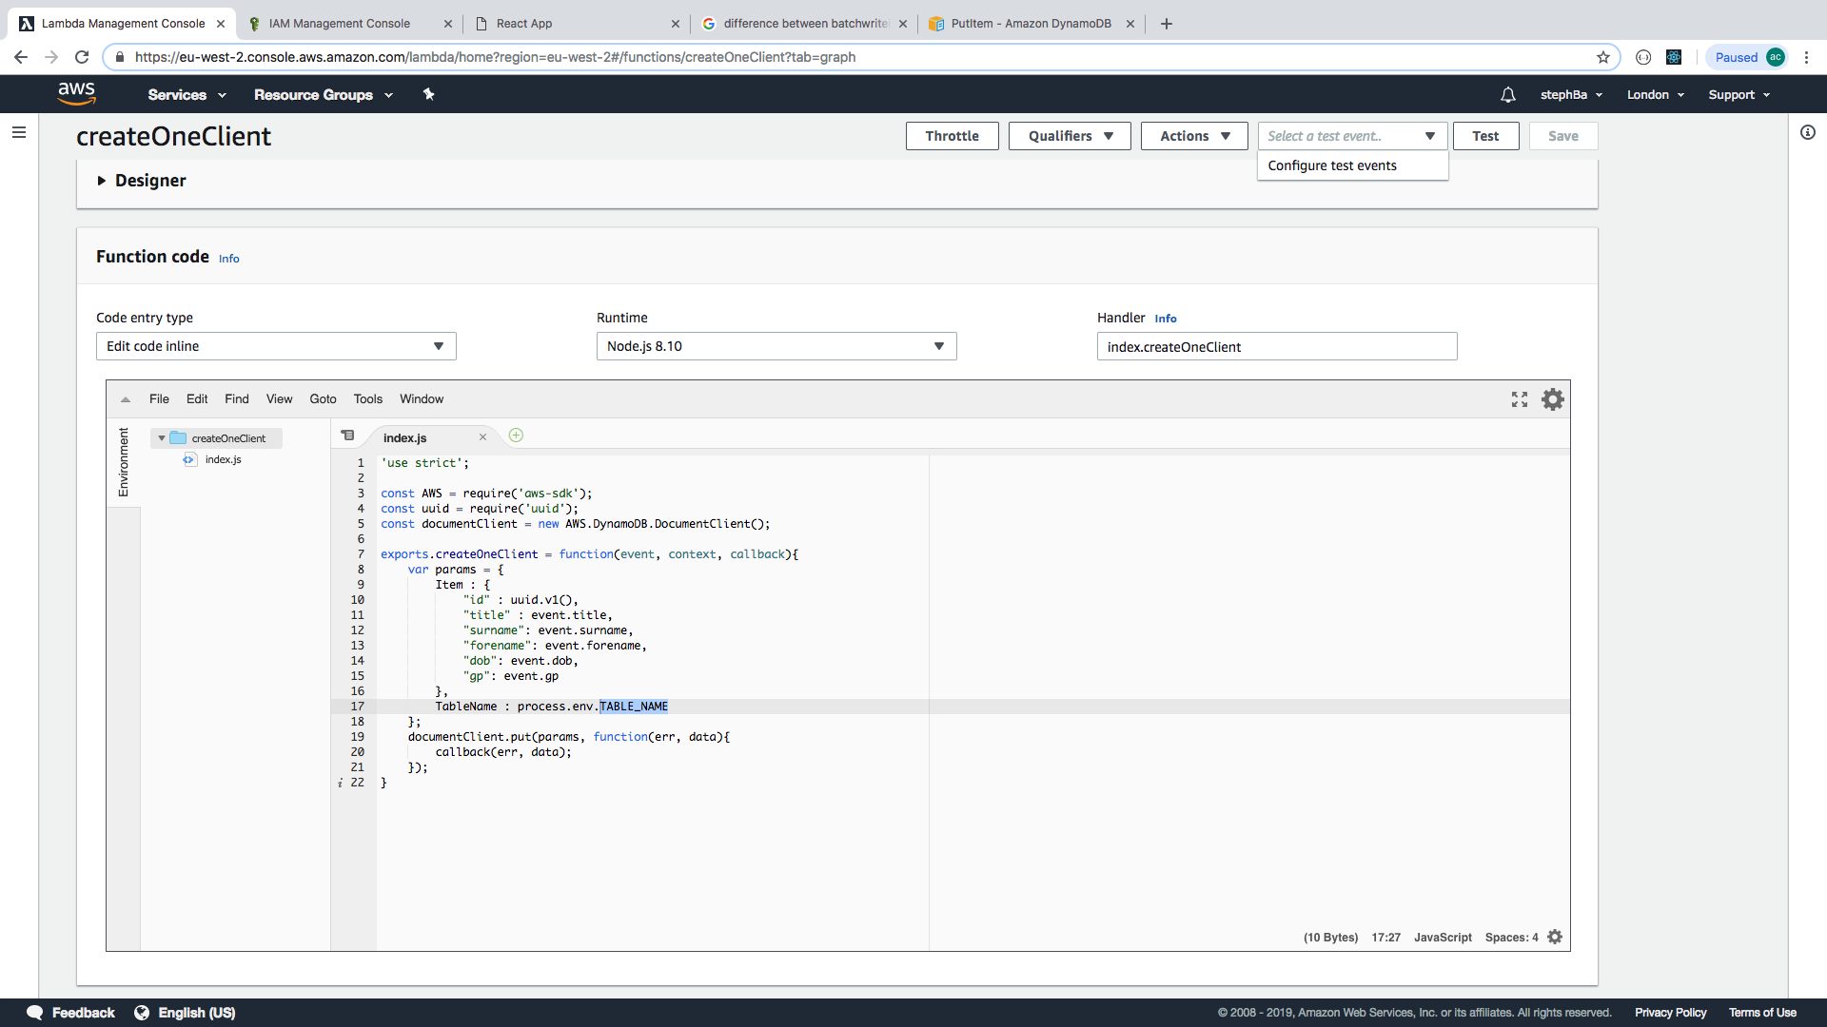

Select ‘configure test events’ from the ‘select a test event’ dropdown.

Note - For example, in the app, the code refers to “title” : event.target.title.value, but for Lambda to access this information, the format is just:

“Title” : event.title,

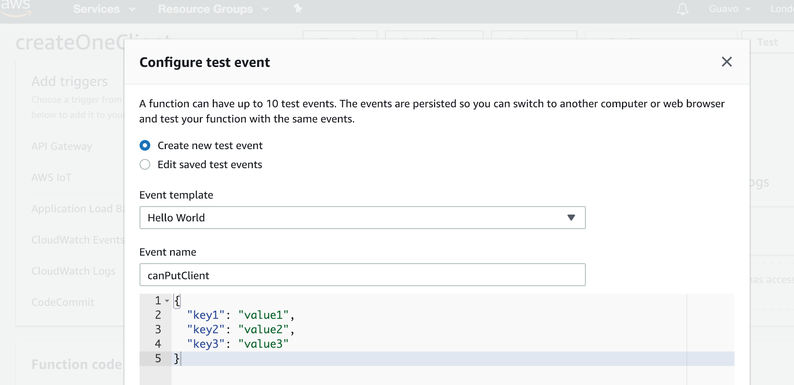

Replace the template with your own test:

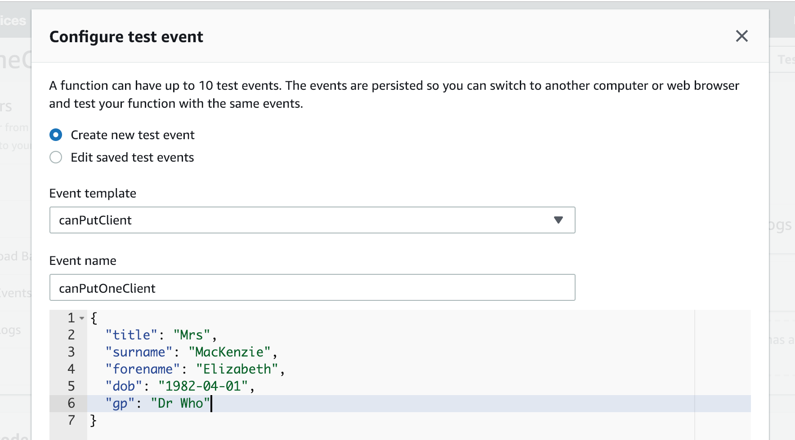

Then run the test, which will give the following if successful:

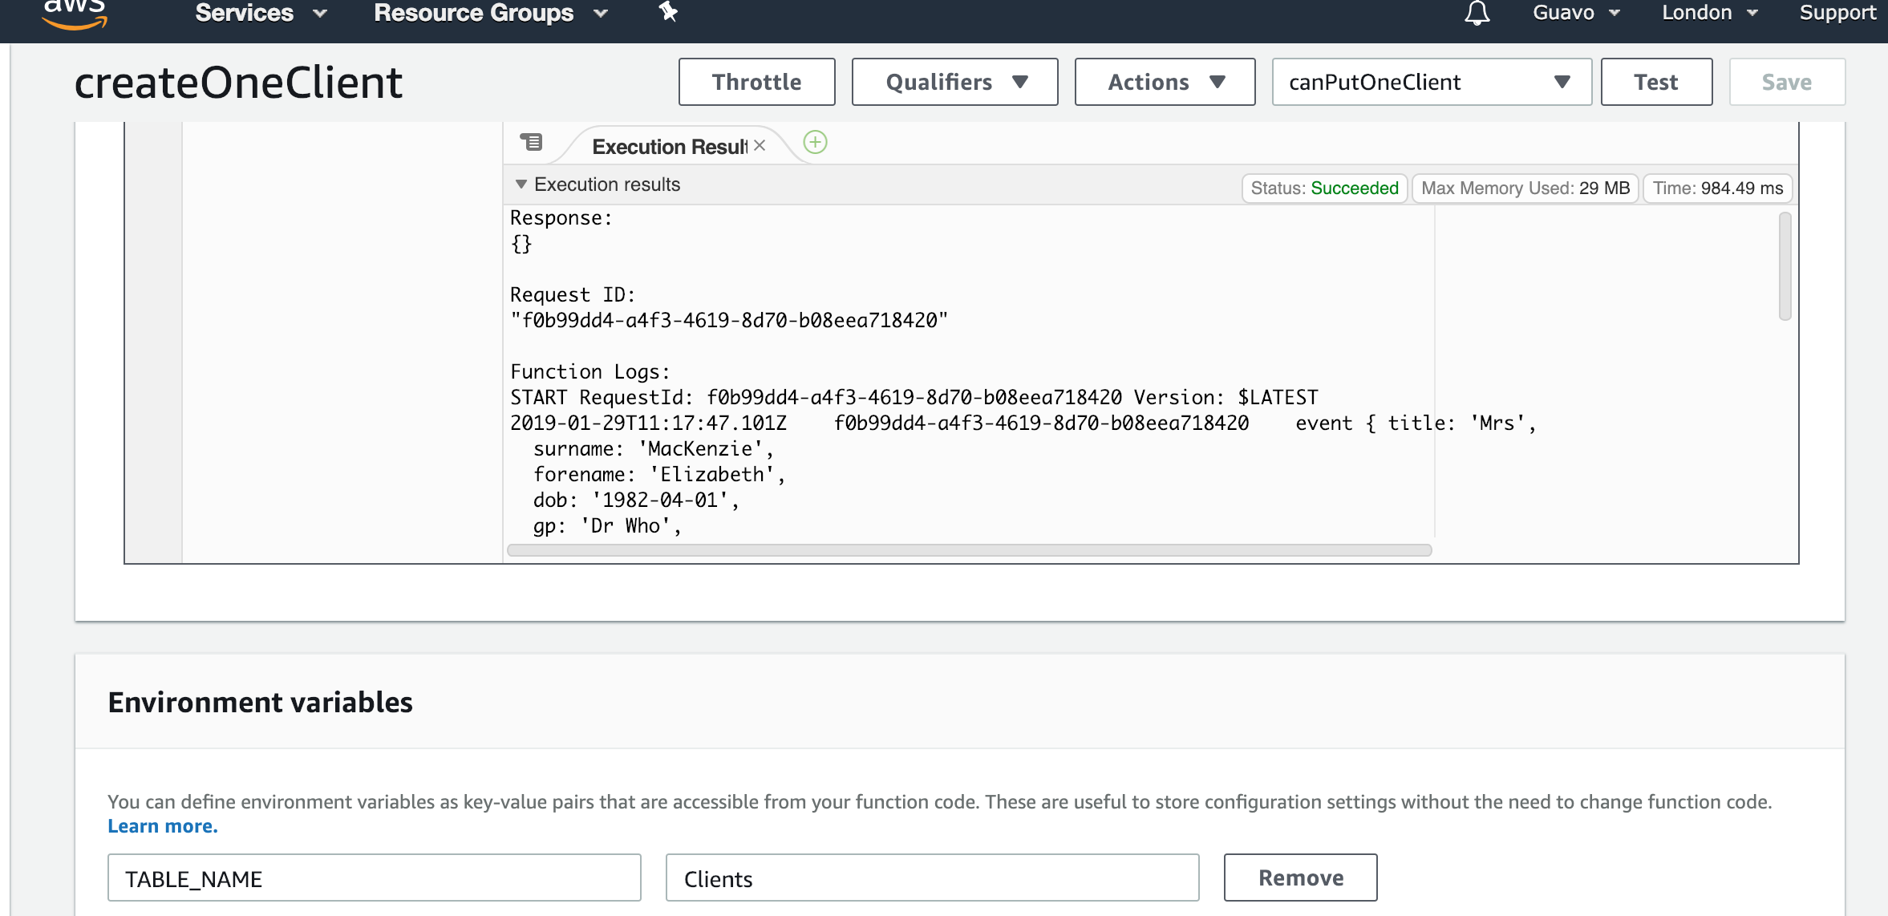

Next up is the API Gateway. Go to services and select API Gateway:

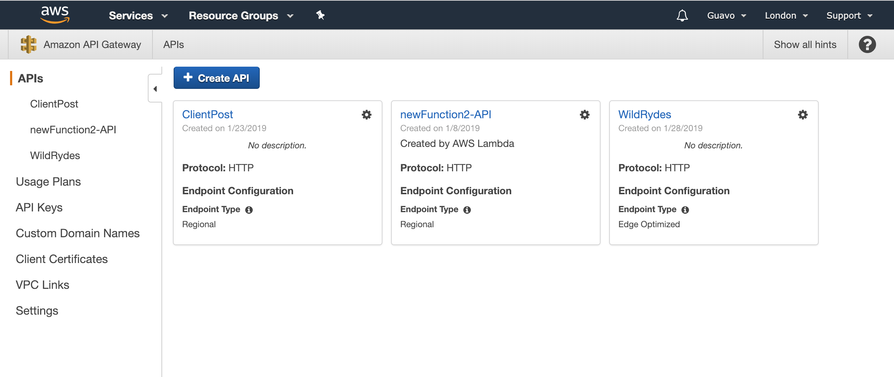

Select Create API, give it a suitable name (we went for PostClient), and select ‘Edge Optimized’, then ‘Create API’:

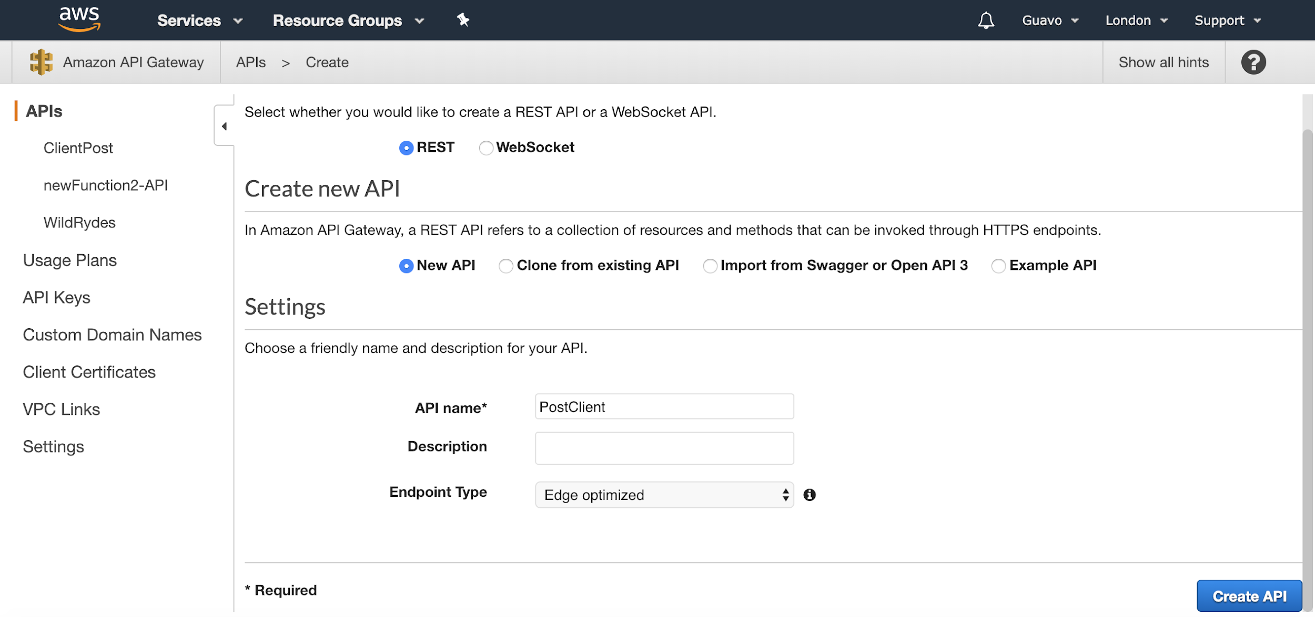

Click on Action to select the Resource and the method or any actions in API.

First we need to create a Resource, to

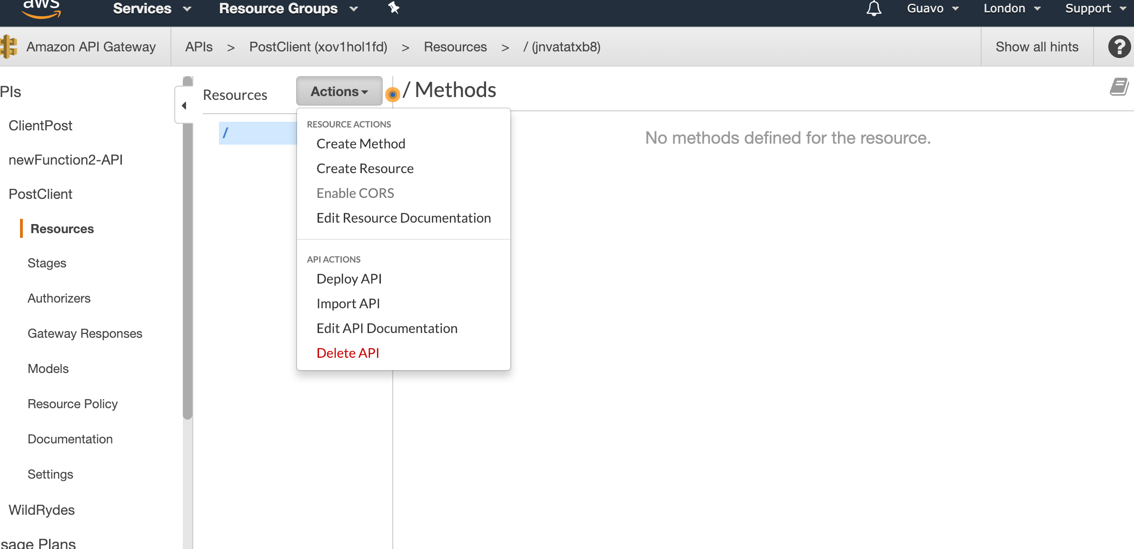

Enter the name of the resource and click on create Resource

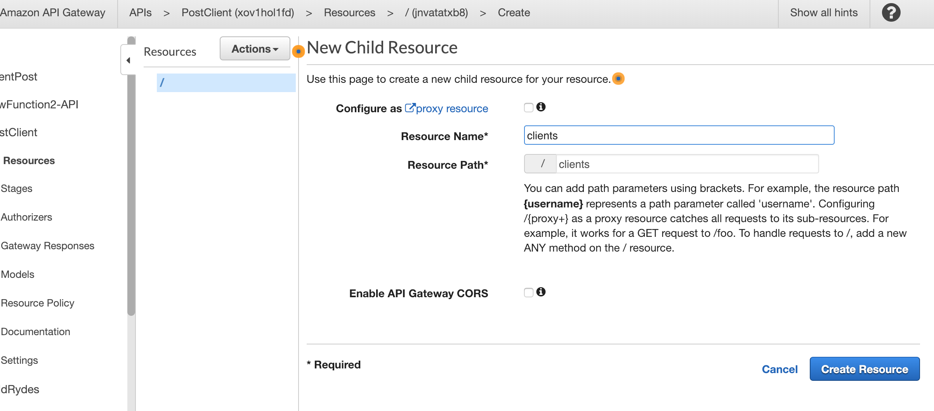

The route will be created. You will need to add method to the resource by clicking create Method.

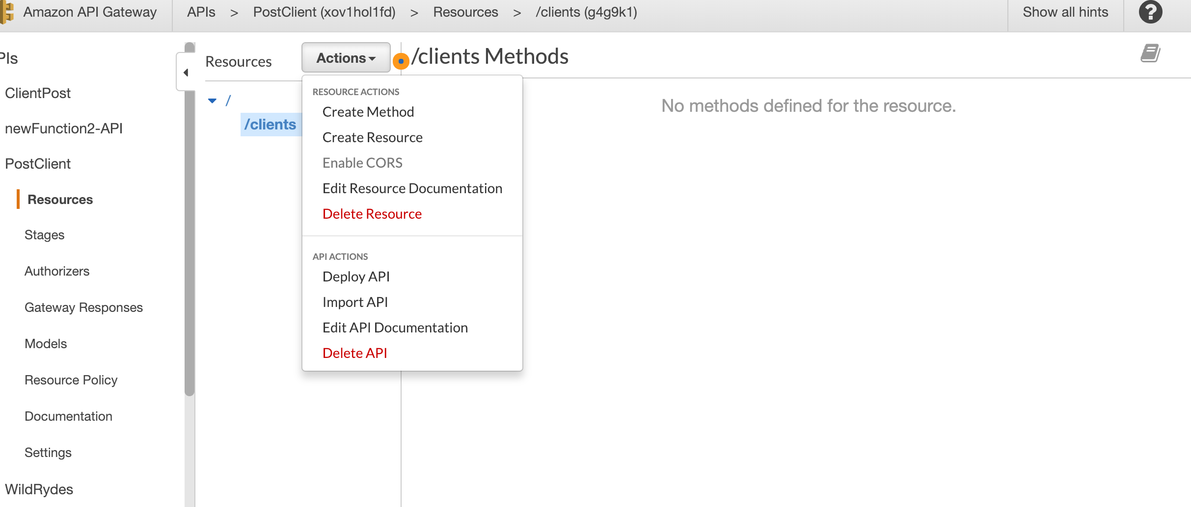

Select the method you want to add in the dropdown menu and click on the tick to confirm.

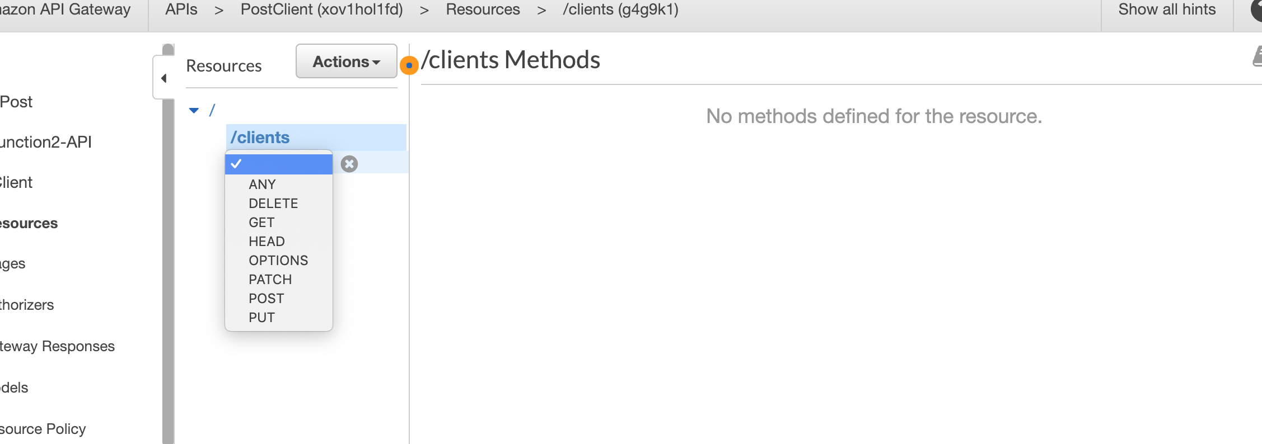

Leave the option by default and enter the name of the lambda function that you want to use for this method, then click on save.

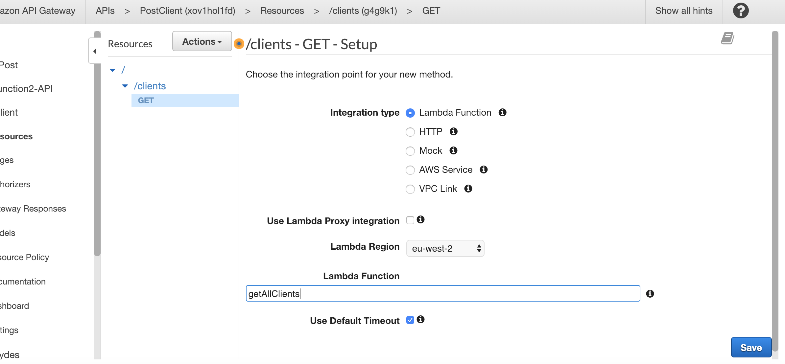

A pop up will ask you to confirm, click on OK

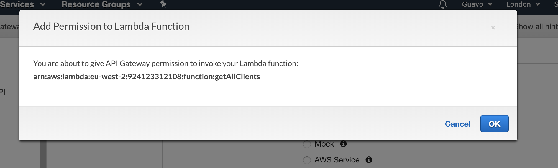

You will be redirected to this page:

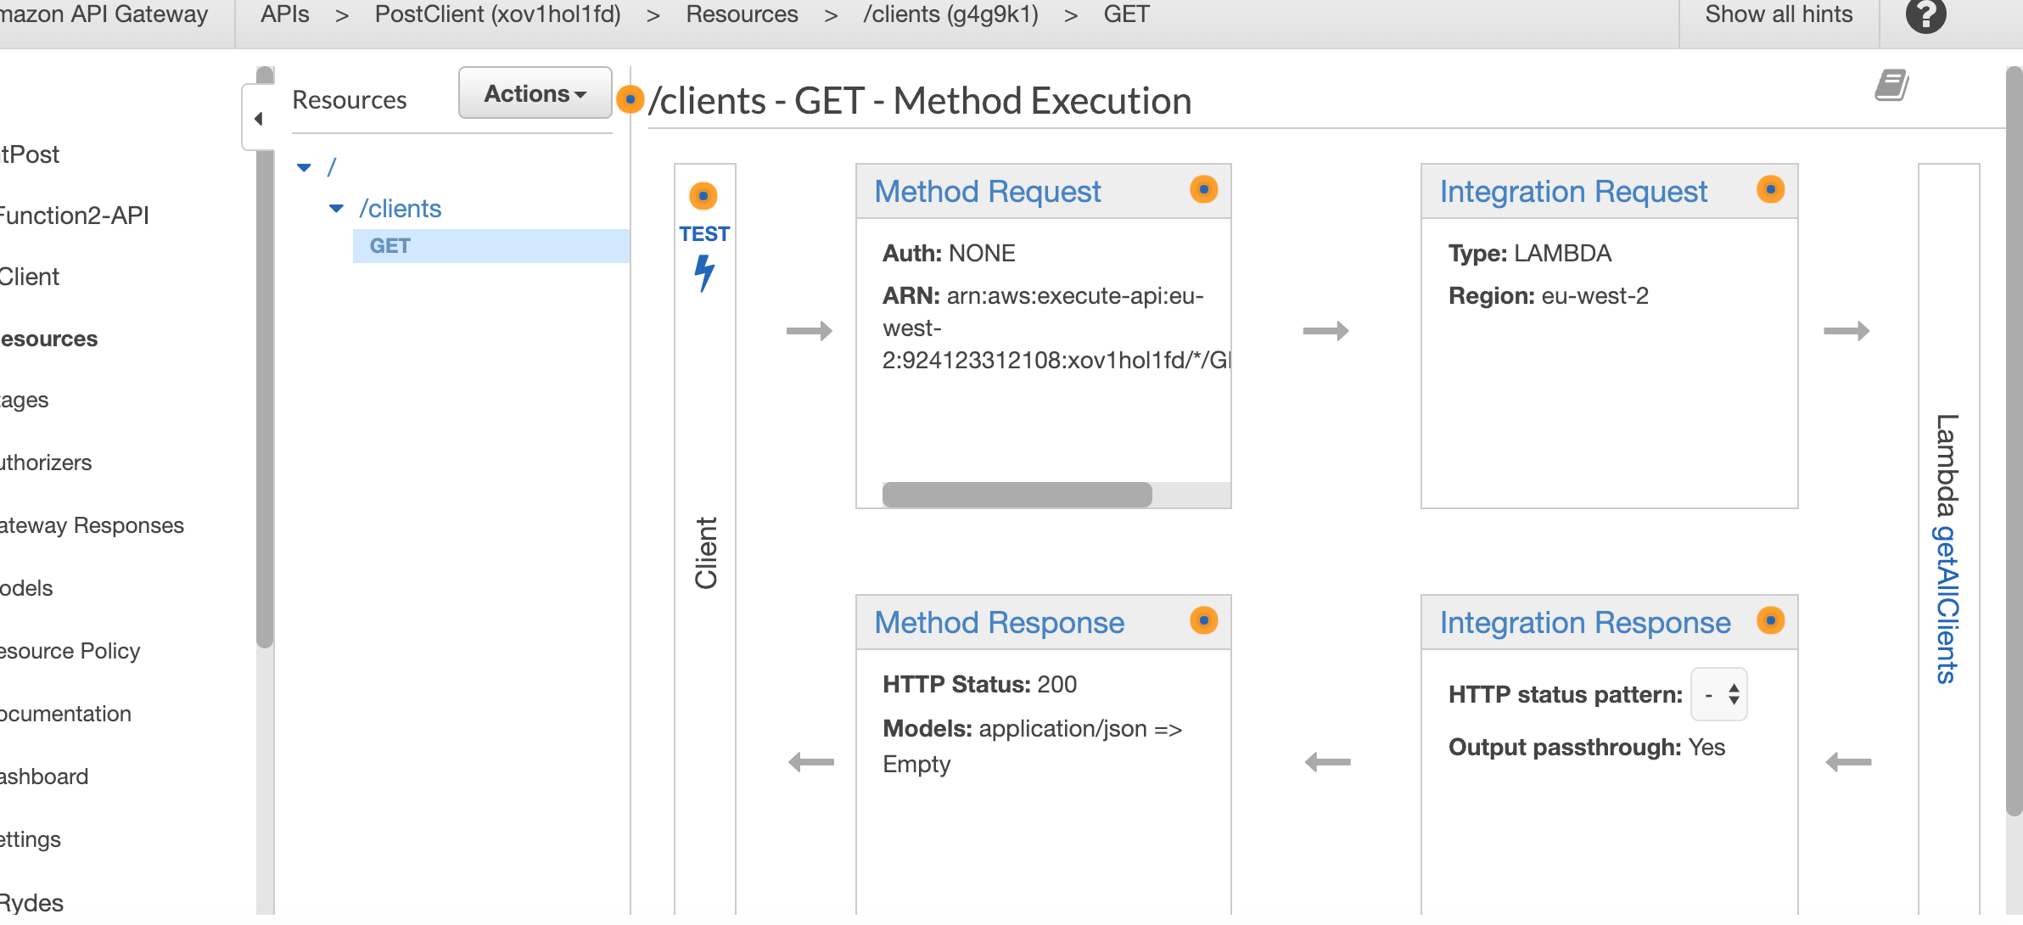

Then select the Resource that you created and select Enable CORS

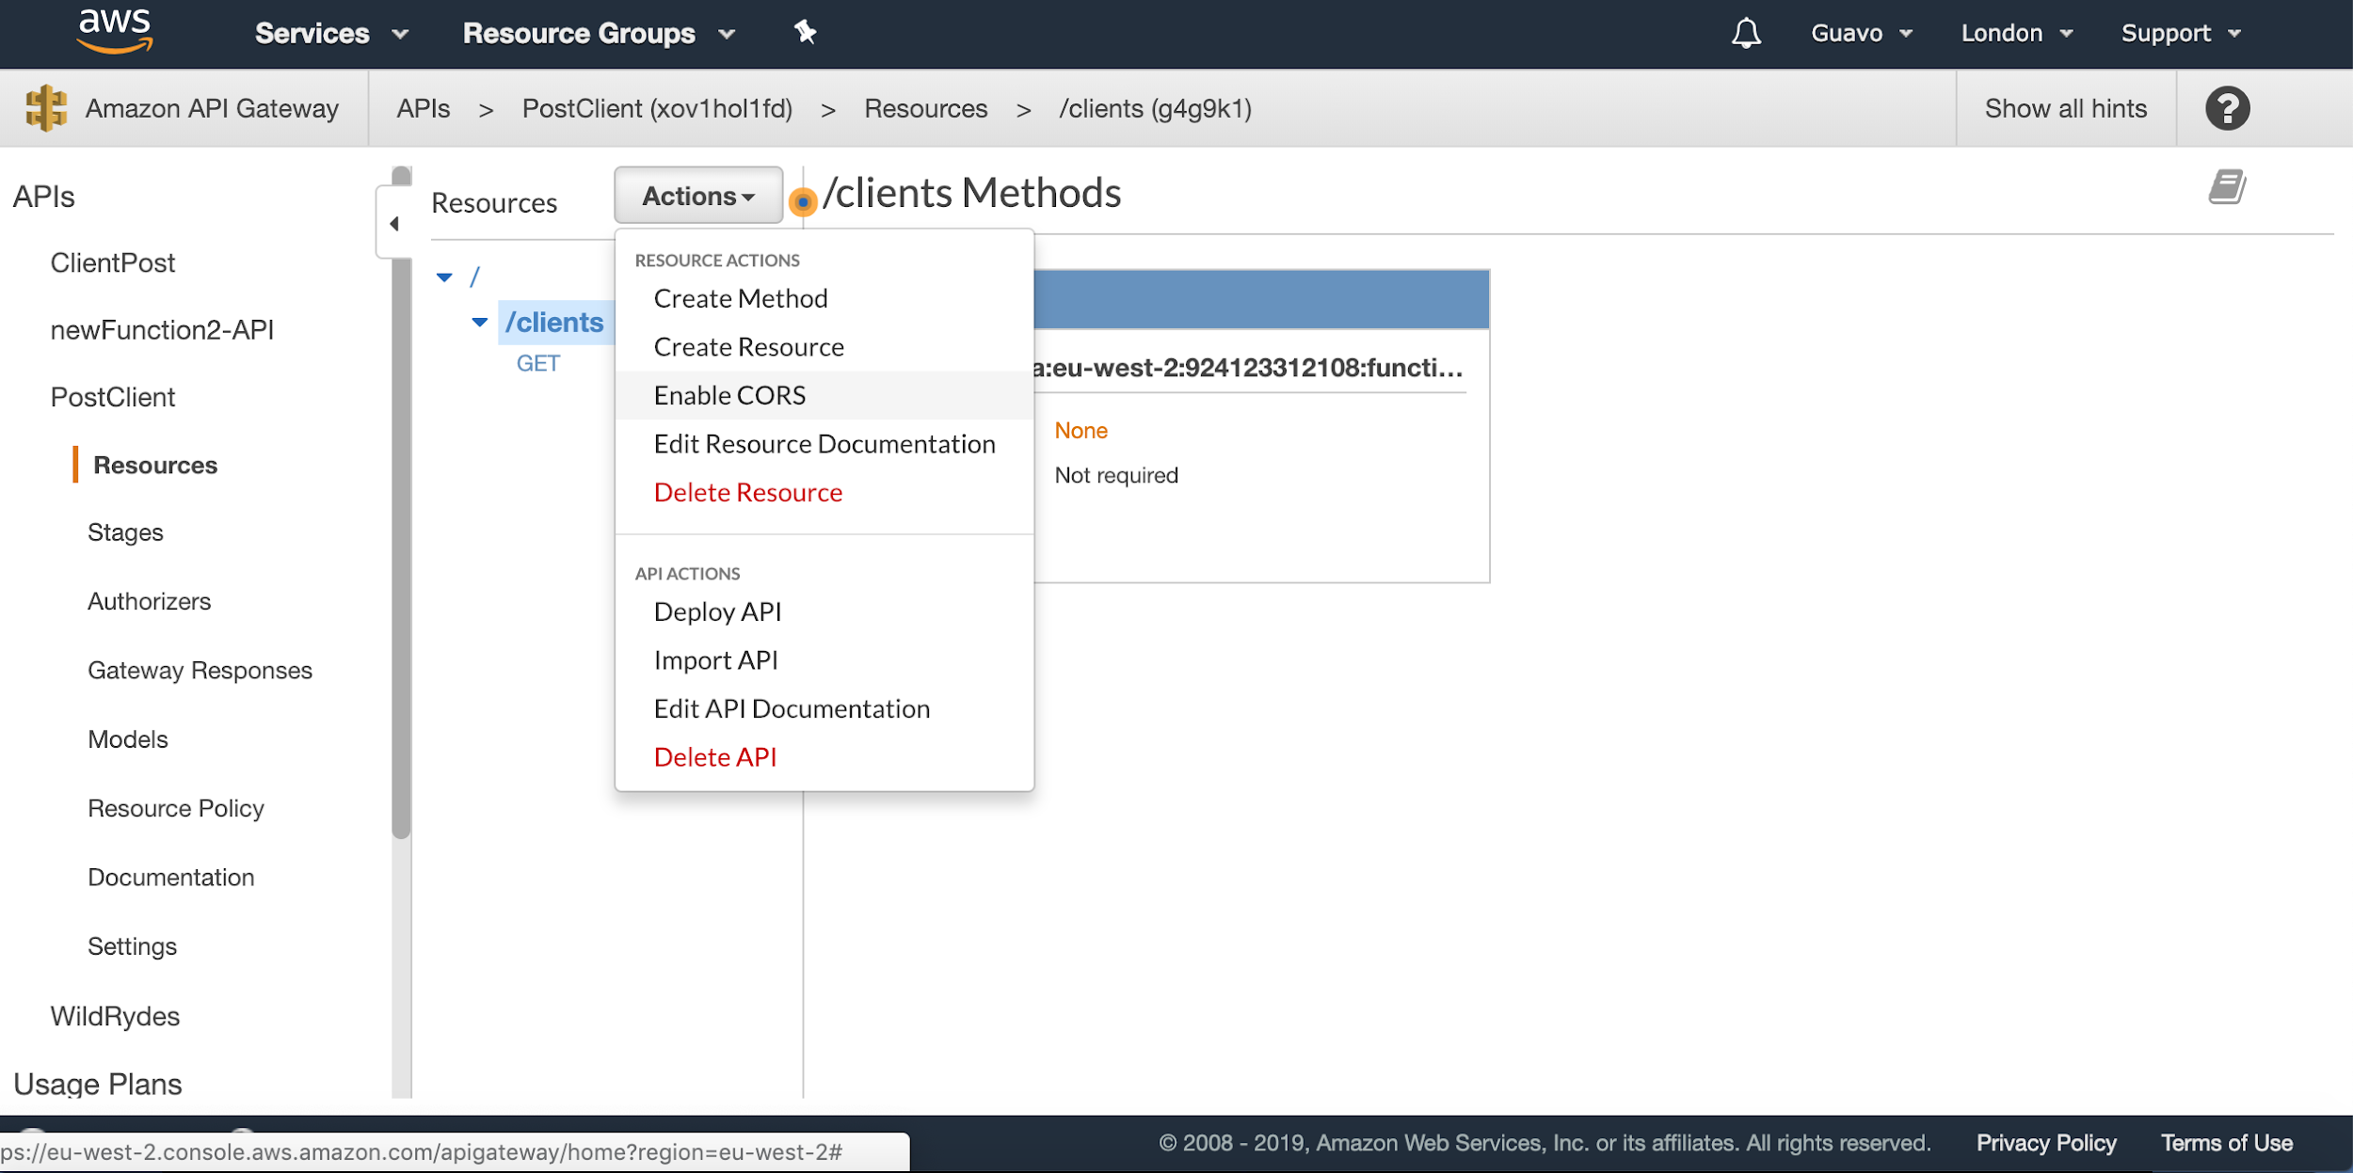

Leave everything by default, and click on Enable CORS

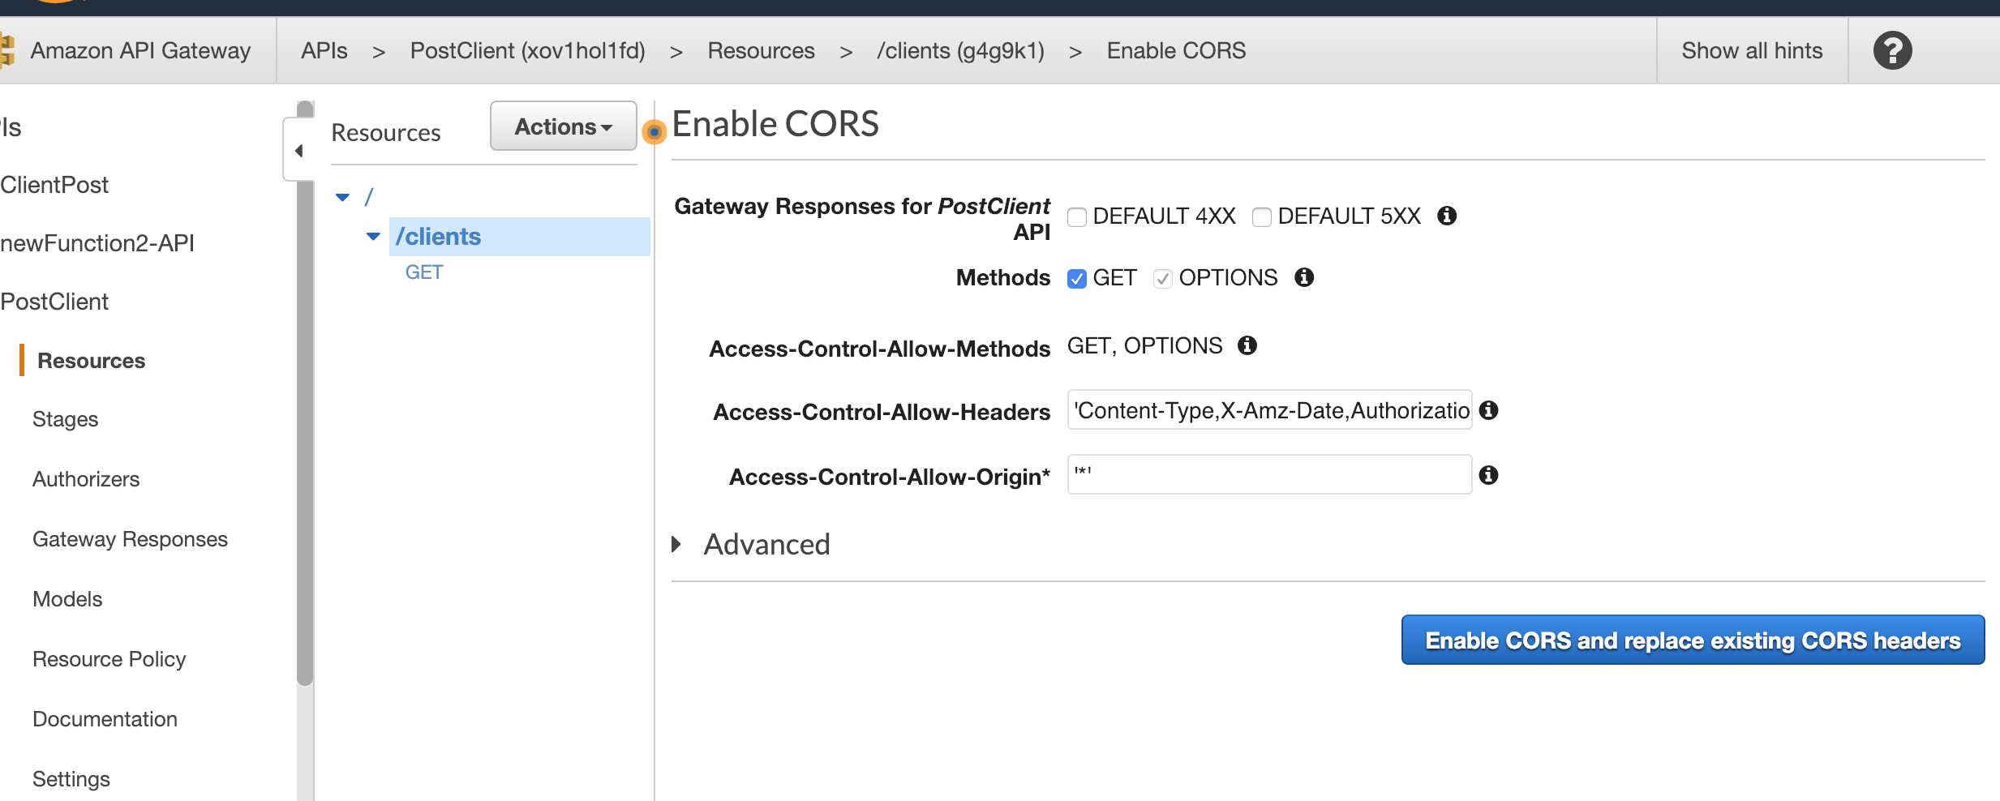

Click on Yes, replace existing values

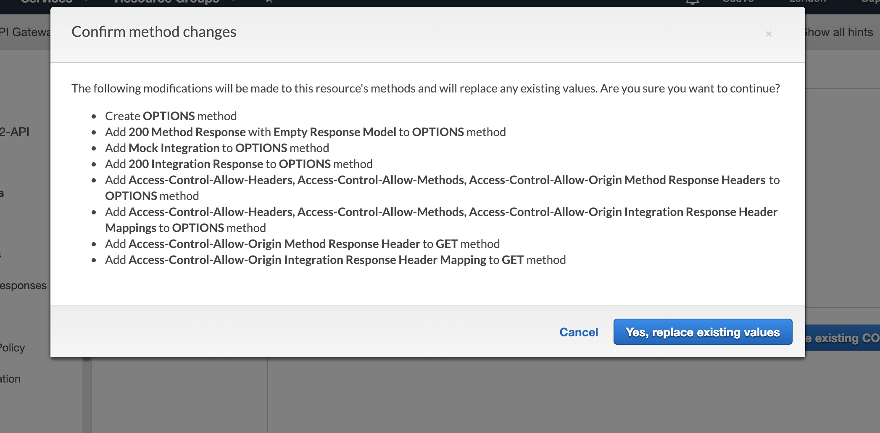

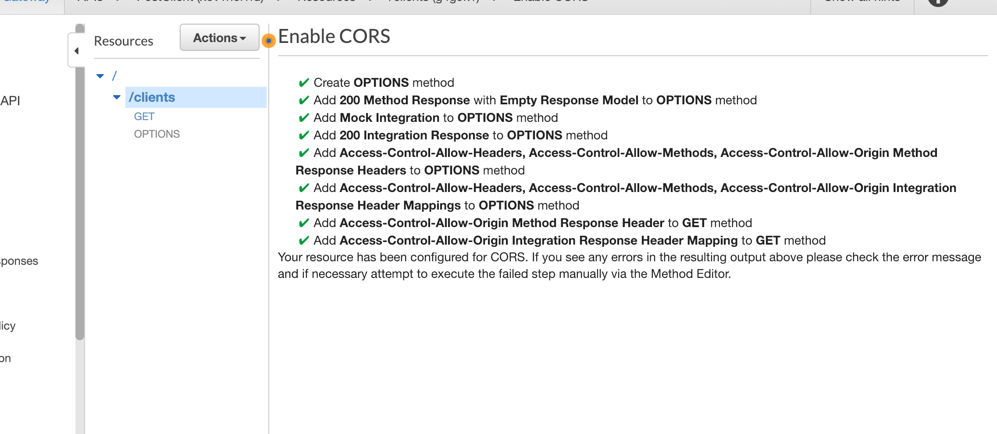

Then under Action select deploy API

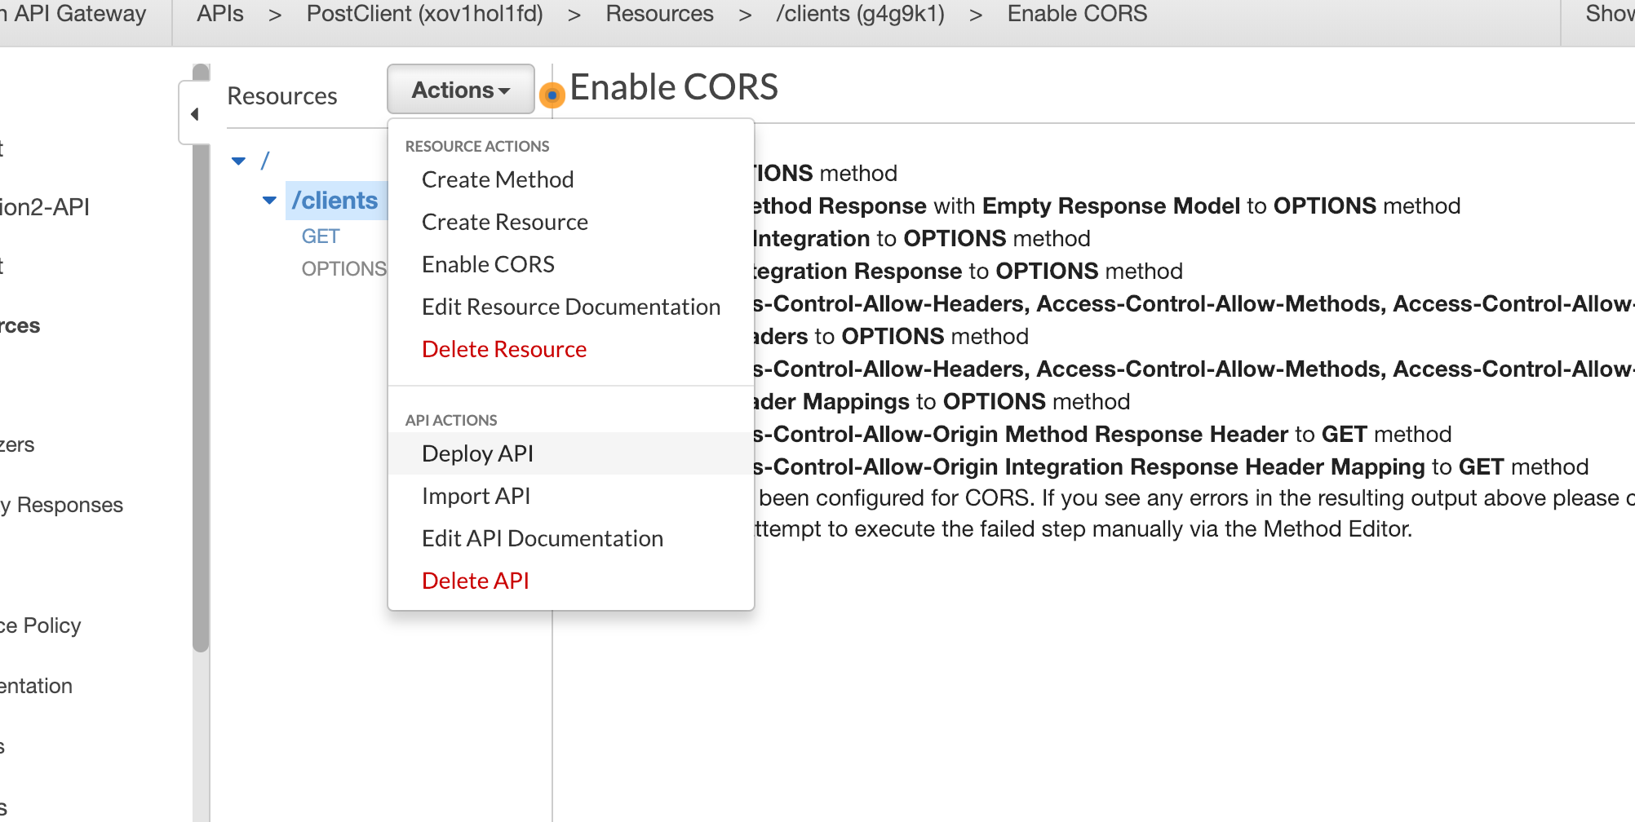

Select New Stage from the dropdown menu

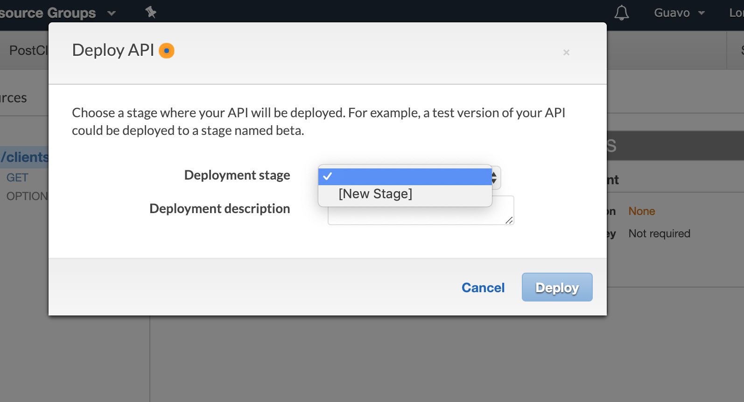

Then enter the name of the stage and click on deploy

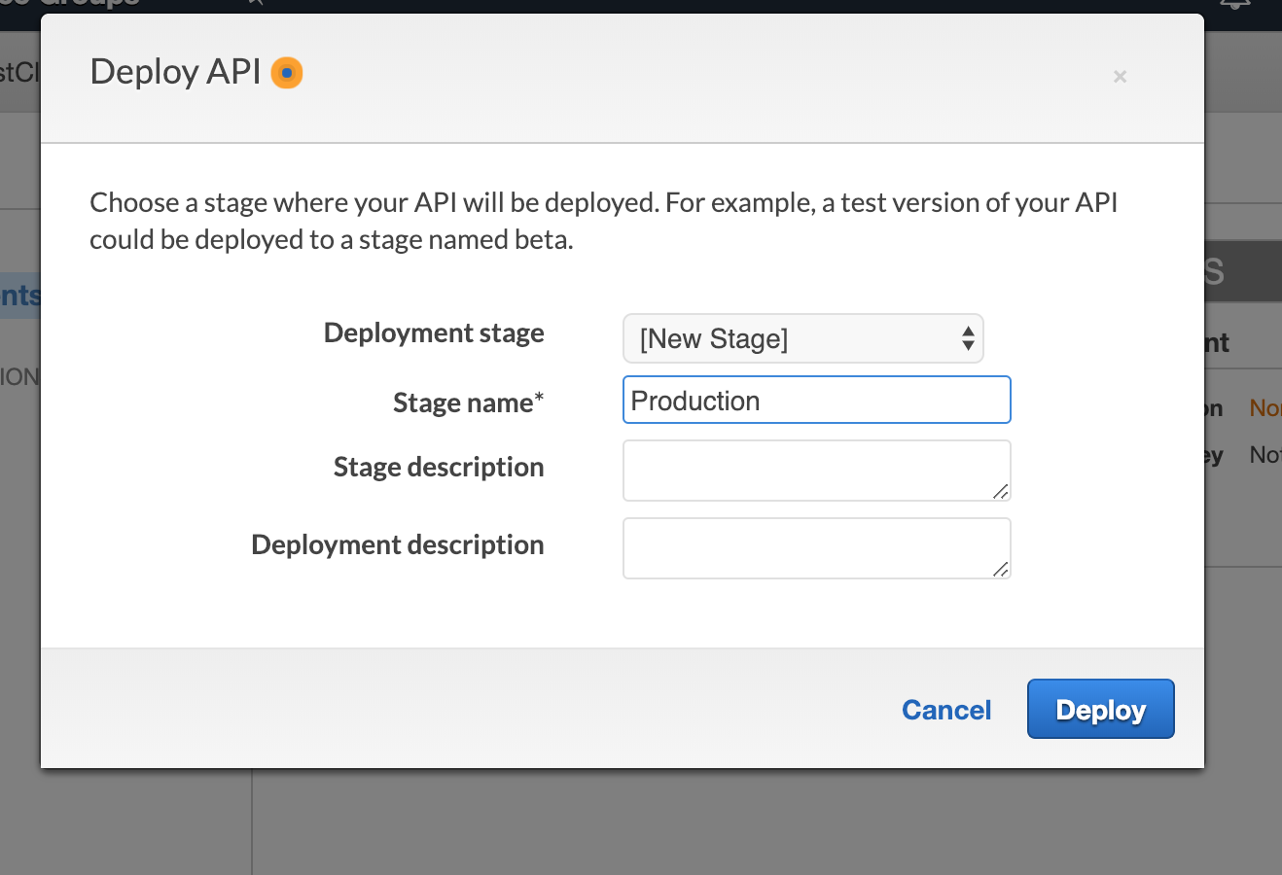

Copy the end point. This is the endpoint of the API that you will use to access the backend

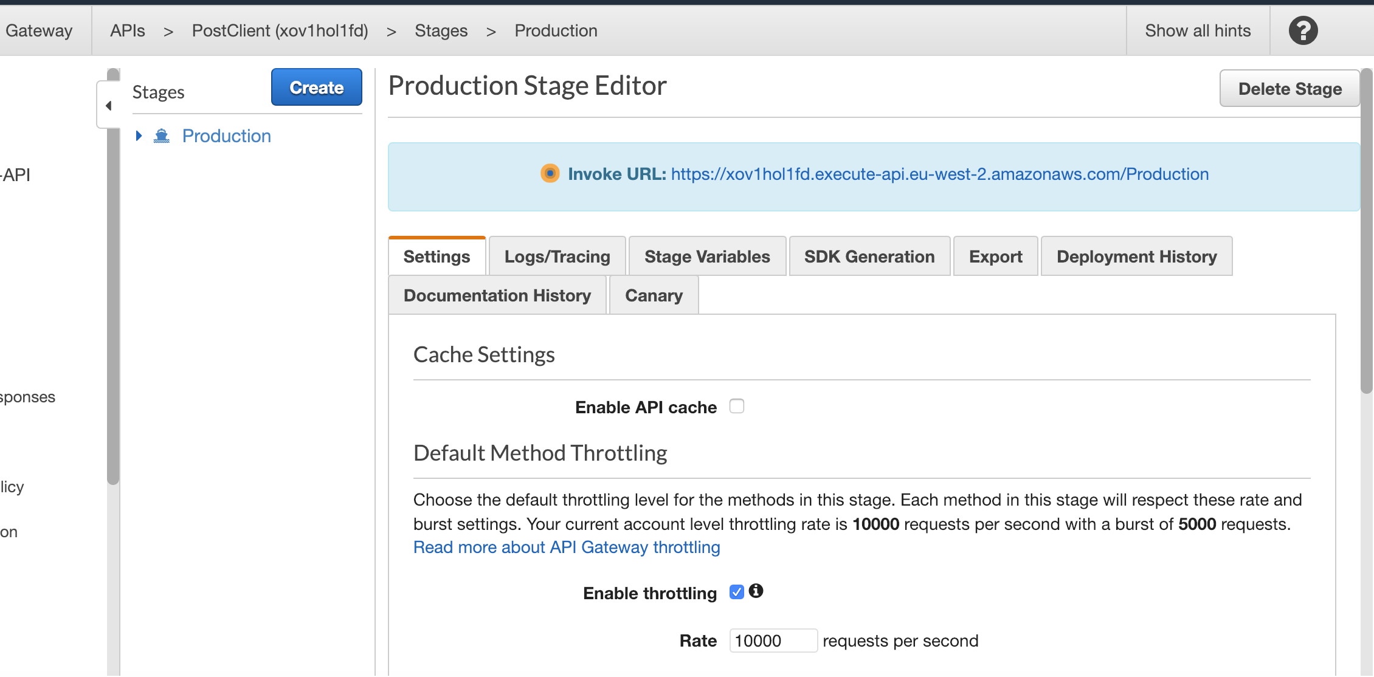

To access the database you need to add the resource to the endpoint:

https://xov1hol1fd.execute-api.eu-west-2.amazonaws.com/Production/clients

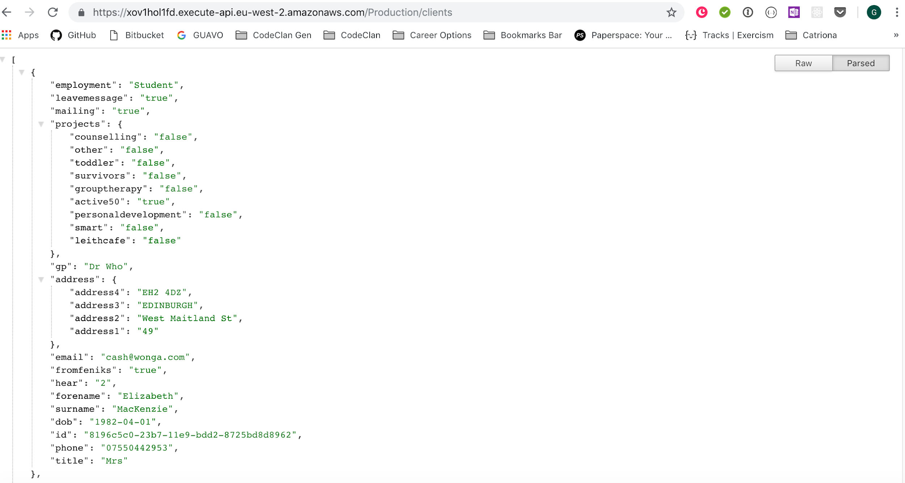

In the React JS Project, the url is only changed in the AwsRoute.js file, where it is exported as a constant and is imported in the files that need to make requests through API Gateway:

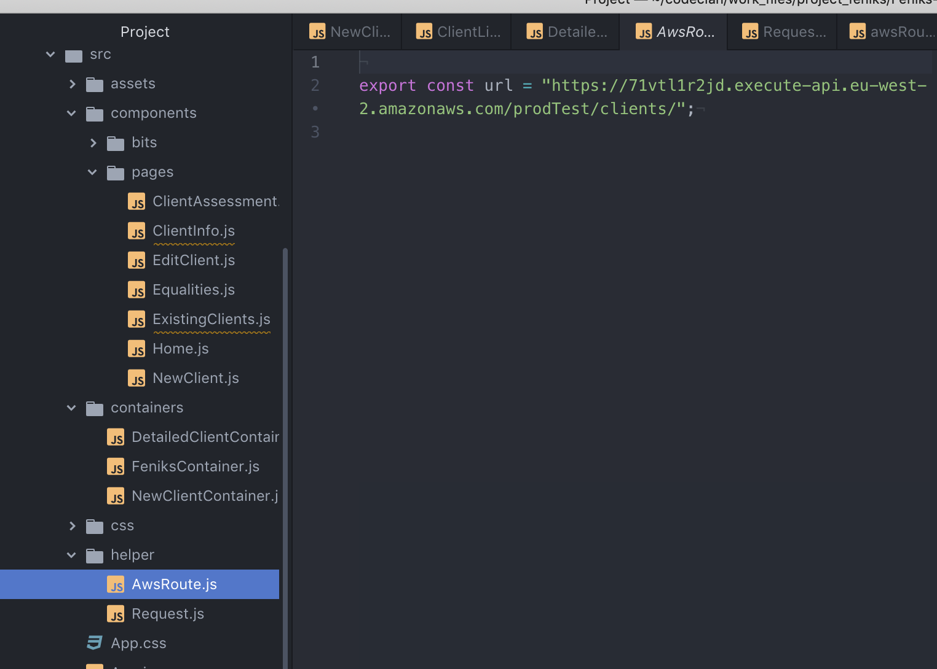

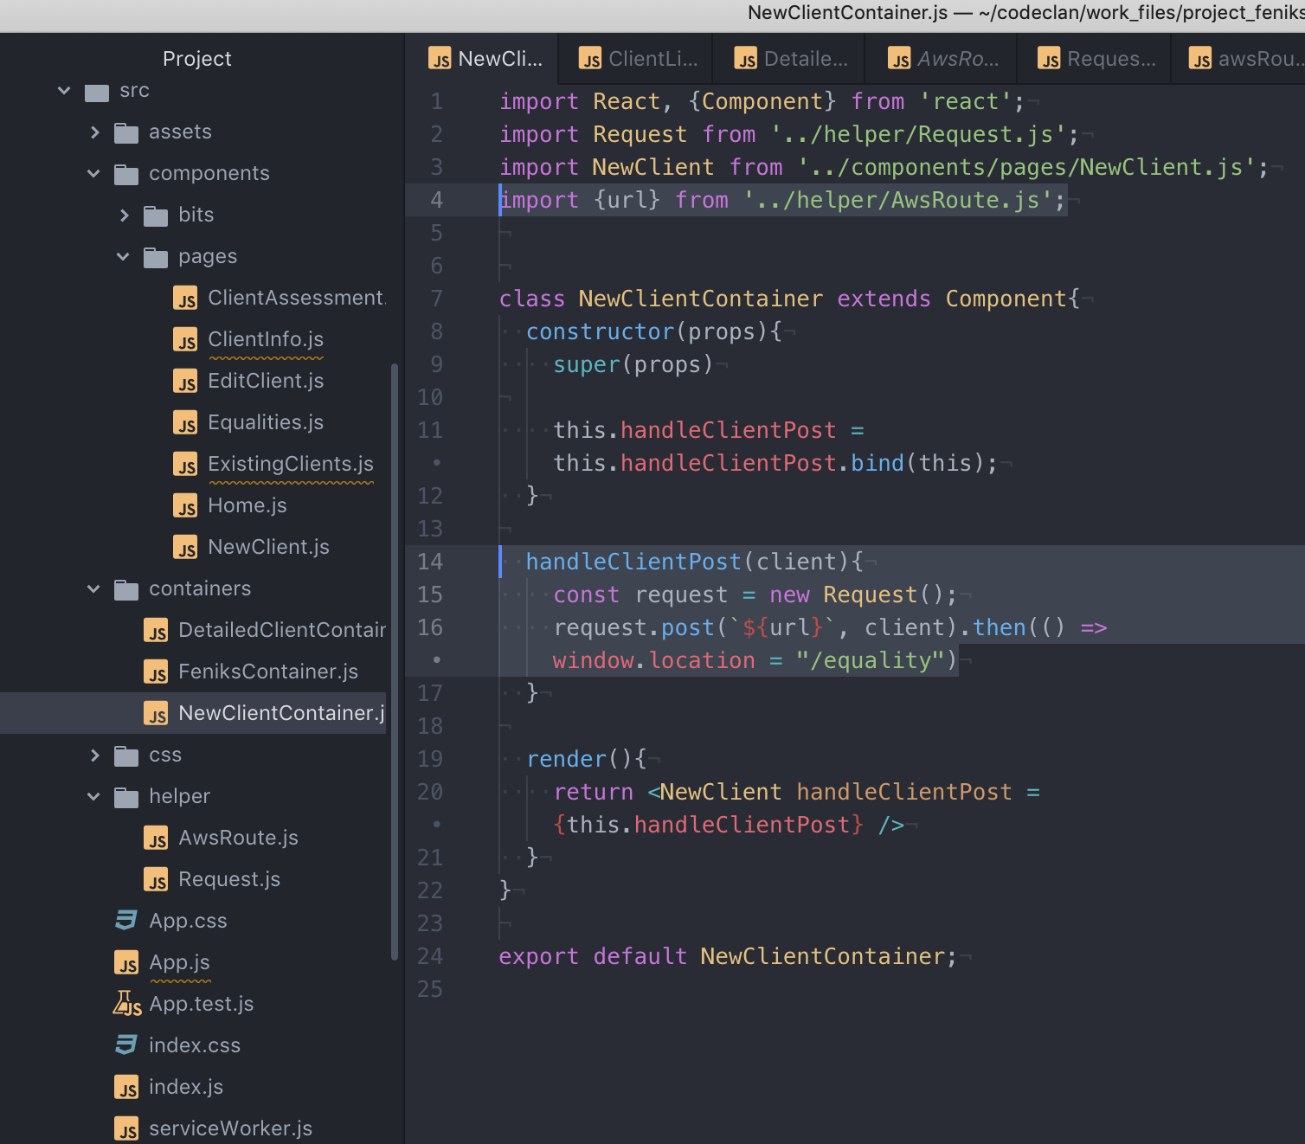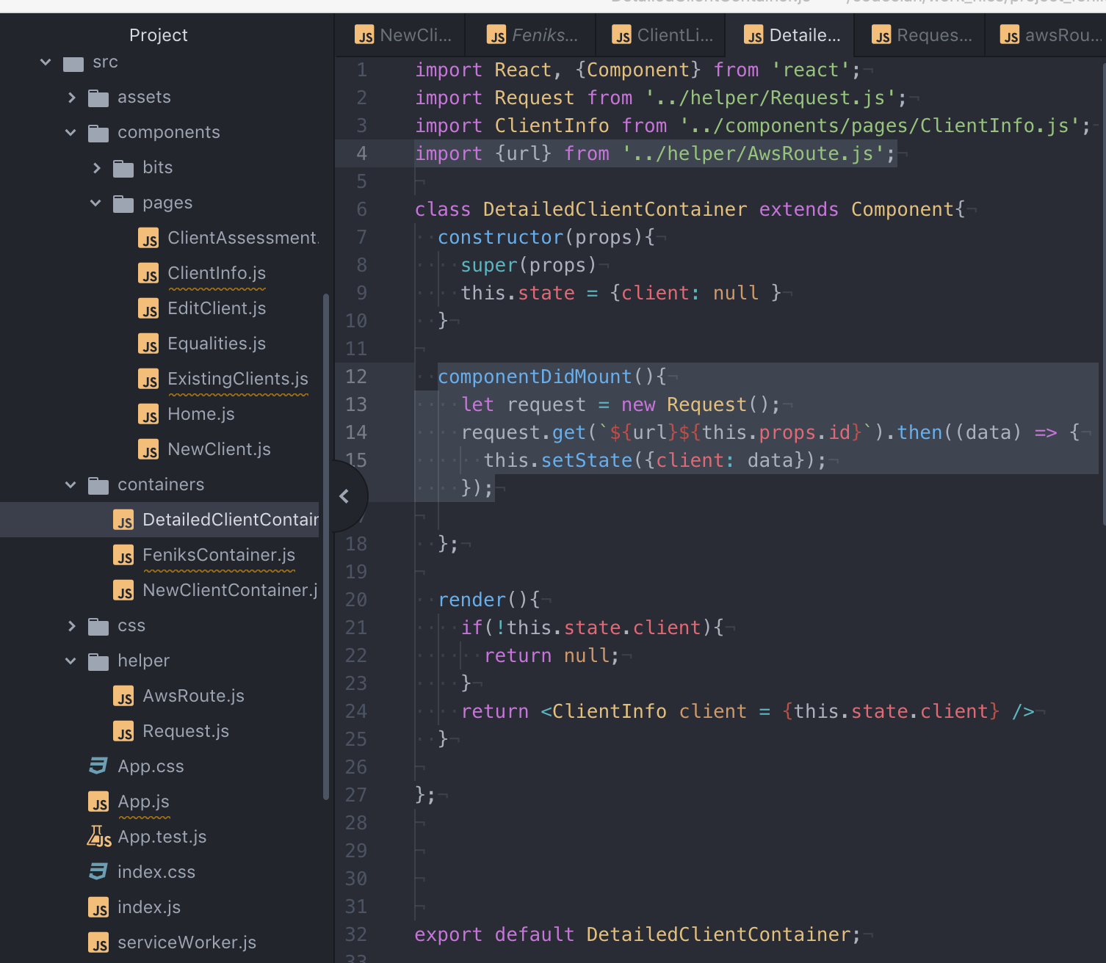

Remember that you can also check the post functionality by looking directly at dynamoDB